# 

# 

**Enterprise Network Design and Deployment**

**Project Lead:** Haim Levhar  
**ID Number:** 329458632 **Instructor:** Itzik Zvi **Year of Execution:** 2025  **School: Sitrin**

**Table of Contents**

1

Project Overview 6

Network Requirements and Solutions 7

Organizational Chart and Departmental Objectives 8

Branch Organizational Overview 9

TechVista Branch 9

Codeport Branch - Main 10

NeoCyberia Branch 11

Physical and Logical Topologies view 12

Physical Topology View 12

Branches Map 12

TechVista Branch 13

CodePort Branch 15

NeoCyberia Branch 17

ISP Pops 19

Logical Topology View 21

Core Network 21

TechVista Branch 22

CodePort Branch 24

NeoCyberia Branch 26

ISPs 28

Network Infrastructure and IP Allocation 29

TechVista Branch 29

Codeport Branch – Main 30

NeoCyberia Branch 31

Equipment Inventory and Access Credentials 32

TechVista Branch 32

Codeport Branch - Main 33

NeoCyberia Branch 34

Servers Config and Domain Mappings 35

TechVista Branch 35

Codeport Branch - Main 35

NeoCyberia Branch 35

AAA Tables 36

TechVista Branch 36

Codeport Branch - Main 36

NeoCyberia Branch 36

VTP Tables 37

TechVista Branch 37

NeoCyberia Branch 37

AP Tables 37

Mail Tables 38

TechVista Branch 38

CodePort Branch 39

NeoCyberia Branch 39

BGP Peer and ISP Network Topology 40

BGP Peer Relationships Table 40

Branch ISP Connectivity and IP Allocation 40

Secure Tunneling and Endpoint Configuration 41

TechVista 41

CodePort 42

NeoCyberia 43

IPSec VPN Device Configuration 44

Phase 1: ISKAMP/IKE Configuration 44

Phase 2: IPSec Configuration 45

Servers Configuration 46

Domain Name System (DNS) 46

Hypertext Transfer Protocol (HTTP/HTTPS) 48

File Transfer Protocol (FTP) 49

Trivial File Transfer Protocol (TFTP) 51

Syslog Protocol 53

Network Time Protocol (NTP) 55

Mail Protocols (SMTP, POP3, IMAP) 57

Authentication, Authorization, & Accounting (AAA) 60

Dynamic Host Configuration Protocol (DHCP) 62

Routing Protocols 64

Open Shortest Path First (OSPF) 64

Enhanced Interior Gateway Routing Protocol (EIGRP - Cisco Proprietary) 65

Border Gateway Protocol (BGP) 66

Layer 3 Protocols 67

Hot Standby Router Protocol (HSRP - Cisco Proprietary) 67

IPsec Virtual Private Network (IPsec VPN) 68

Generic Routing Encapsulation (GRE) 69

EtherChannel (Cisco Proprietary) 70

Layer 2 Protocols 71

VLAN Trunking Protocol (VTP - Cisco Proprietary) 71

Rapid Spanning Tree Protocol (RSTP - IEEE 802.1w) 72

Trunking (IEEE 802.1Q - Dot1Q) 73

Miscellaneous IOS Commands 74

Device Identification and Basic Configuration 74

Security, Authentication, and Line Connections 75

Logging and Monitoring 78

Banner and User Access 79

VLAN and Interface Management 79

Routing and ACL Management 80

Maintenance and Operational Commands 80

ACKNOWLEDGEMENTS

First and foremost, I would like to express my immense gratitude to the *Almighty* for granting me the opportunity, patience, and perseverance throughout the entire execution of the project, both during the learning phase and the implementation phase.

Wendell Odom, whose CCNA series has significantly impacted this project, was priceless to me during this time. I want to thank *Yishai Shobali*, a considerate person who facilitated me and suggested great ideas throughout this development. I would also like to thank *Ariel Levi,* a great individual who helped me solidify my understanding of concepts and strengthen my troubleshooting skills along this journey. Thanks to *Itzik Tzvi* for his suggestions of improvements and revisions that I did not notice along crucial modifications executed to be in accordance with the network requirements, transforming this project to a near-perfection with respective to its requirements. Thanks to classmates who had taken part in this project. Additionally, I would like to acknowledge *Chat GPT* for its valuable assistance in handling the more tedious aspects of this process.

# Project Overview

**Company Profile: Mentora Nexus**

**Founders:** Yami Sukehiro, Eran Yeager  
**Industry Sectors:** Academic Publishing, E-Learning, Technology  
**Revenue:** $75 million (2024)  
**CEO:** Light Yagami

Mentora Nexus is a leading provider of academic resources focused on computer science, based in Innovation Valley, California, USA. Founded in 2010 by Yami Sukehiro and Eran Yeager, the company began as a specialized library dedicated to programming, software engineering, and related computer science disciplines. Over the years, Mentora Nexus has evolved into a trusted name in digital learning, offering high-quality textbooks, AI-powered study tools, and customized learning resources.

With a focus on empowering students and professionals, Mentora Nexus launched its e-commerce platform in 2015, providing global access to curated academic materials. The organization has introduced AI-driven learning paths and personalized recommendations to enhance the educational experience for users at all levels.

Mentora Nexus specializes in advanced topics such as artificial intelligence, data science, and cybersecurity, aligning with your interest in computer science and philosophy-based approaches to learning. The company also emphasizes sustainable practices, including digital-first solutions and carbon-neutral initiatives.

In the coming years, Mentora Nexus aims to expand access to rare academic materials, foster global academic communities, and continue innovating in the field of computer science education.

The main branch, branch 1, and branch 2 are located on **CodePort**, **TechVista**, and **NeoCyberia**, respectively.

# 

# Network Requirements and Solutions

|  |  |
| --- | --- |
| **Network Requirement** | **Solutions** |
| Manage company emails and enable email exchange between employees. | Set up **POP3** and **SMTP** servers. |
| Provide internal storage for company files. | Establish **FTP** servers for secure storage and retrieval of internal organizational data. |
| Enable employee access to client management applications and data through user-friendly domain names instead of IP addresses. | Set up internal **WEB servers** and implement a **DNS server** to translate IP addresses into domain names. |
| Ensure fast communication between company branches. | Use **Metro Ethernet** infrastructure with fiber-optic connectivity provided by the ISP. |
| Maintain smooth, fast, and load-free internal network traffic. | Design an optimized network structure, implement **VLANs** for different departments, and divide into subnets. |
| Allow the network administrator to manage the network remotely. | Enable remote access (**VTY**) to routers and switches. |
| Provide wireless internet access for employees and visitors. | Implement wireless access points (**WAPs**) for secure connectivity via mobile phones, tablets, and laptops. |
| Enable selective internet access for certain employees. | Connect to an ISP and implement **ACLs** on the outbound router. |

# 

# Organizational Chart and Departmental Objectives

# 

# Branch Organizational Overview

## TechVista Branch

|  |  |  |
| --- | --- | --- |
| **Department Name** | **Objective** | **Number of Employees** |
| Management | Oversee and direct overall operations to ensure alignment with the organization's mission, vision, and strategic goals | 10 |
| Information Technology (IT) | Manage and develop the technological infrastructure supporting both physical and digital operations, ensuring a seamless user experience | 7 |
| Academic Publishing | Curate and publish high-quality academic textbooks, with a focus on emerging fields such as artificial intelligence, data science, and cybersecurity | 7 |
| Technology & Innovation | Integrate advanced technologies into services, including AI-driven recommendations and personalized learning resources | 7 |
| Human Resource (HR) | Manage recruitment, training, and employee relations to foster a positive and productive work environment | 7 |
| Finance | Handle financial planning, budgeting, and resource management to ensure the economic sustainability of the organization | 8 |

## Codeport Branch - Main

|  |  |  |
| --- | --- | --- |
| **Department Name** | **Objective** | **Number of Employees** |
| Management | Oversee and direct overall operations to ensure alignment with the organization's mission, vision, and strategic goals | 11 |
| Information Technology (IT) | Manage and develop the technological infrastructure supporting both physical and digital operations, ensuring a seamless user experience | 8 |
| Digital Library | Manage the digital collection of textbooks and resources, making them accessible globally and supporting eco-friendly initiatives | 8 |
| Customer Support | Provide assistance and support to users, ensuring a positive customer experience. | 8 |
| Marketing | Promote the organization's services and products to expand reach and brand recognition within the academic community. | 8 |
| Data Analysis | Analyze data to drive decision-making, improve services, and tailor resources to meet users' needs | 9 |

## 

## 

## NeoCyberia Branch

|  |  |  |
| --- | --- | --- |
| **Department Name** | **Objective** | **Number of Employees** |
| Management | Oversee and direct overall operations to ensure alignment with the organization's mission, vision, and strategic goals | 9 |
| Information Technology (IT) | Manage and develop the technological infrastructure supporting both physical and digital operations, ensuring a seamless user experience | 6 |
| Research & Development | Innovate and develop new products, services, and technologies to enhance the learning experience. | 6 |
| Quality Assurance | Ensure that all products and services meet high standards of quality and reliability | 6 |
| Operations | Manage day-to-day activities to ensure efficiency and effectiveness in all aspects of the organization's operations | 6 |
| Business Development | Identify new business opportunities, partnerships, and growth strategies. | 7 |

# Physical and Logical Topologies view

## Physical Topology View

### Branches Map

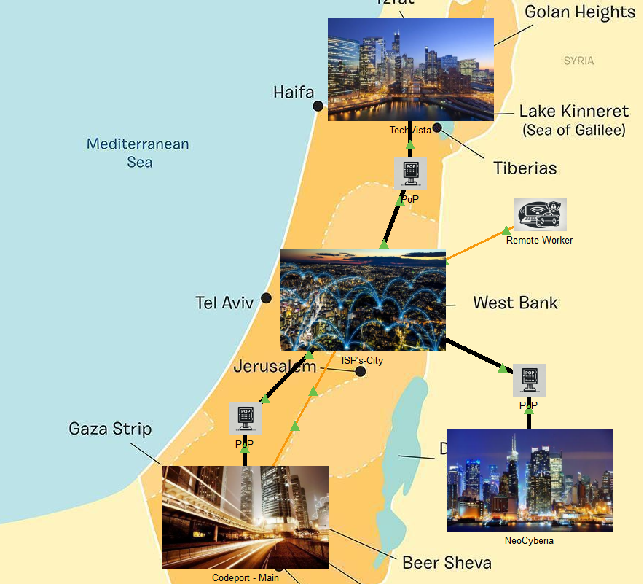

### TechVista Branch

**First Floor**

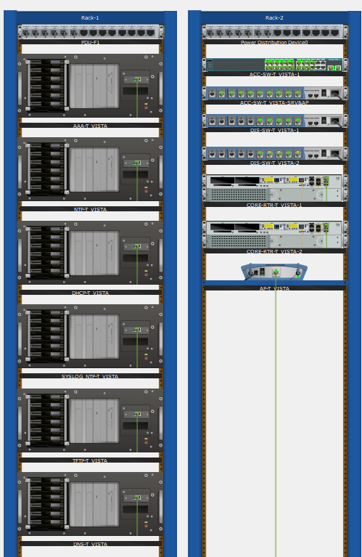

**Second Floor**

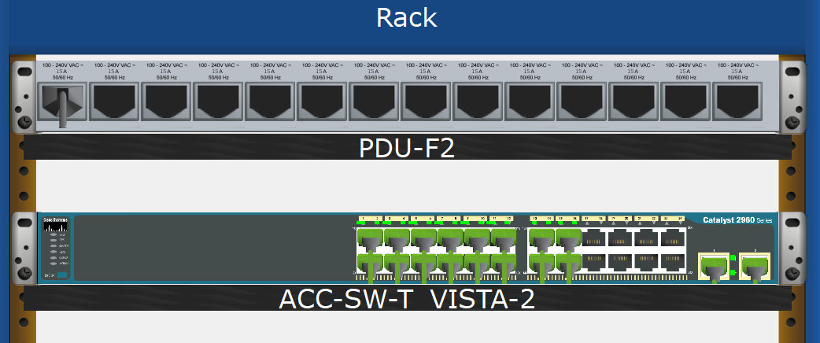

**Third Floor**

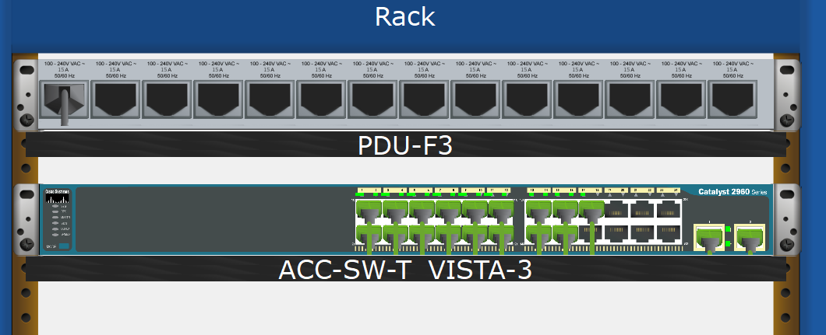

### CodePort Branch

**First Floor**

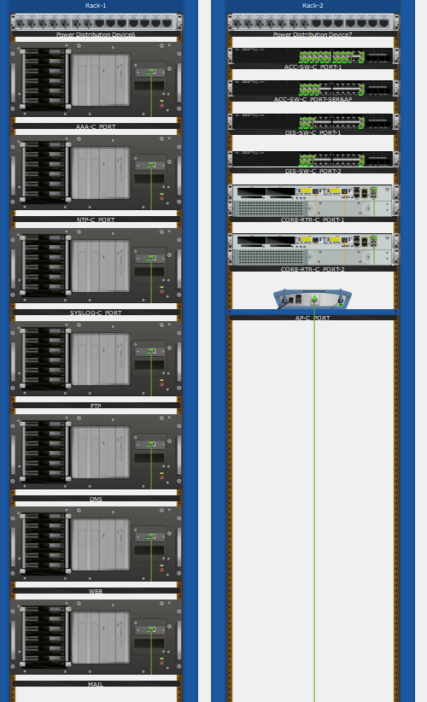

**Second Floor**

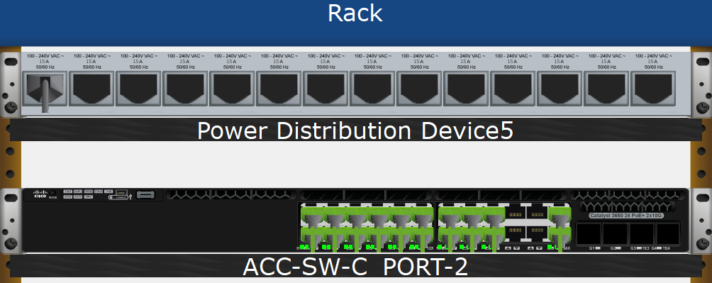

**Third Floor**

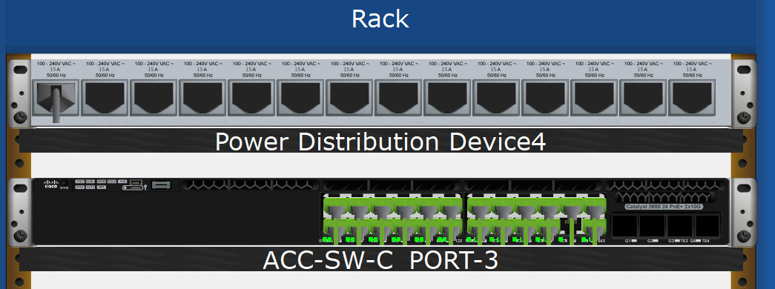

### NeoCyberia Branch

**First Floor**

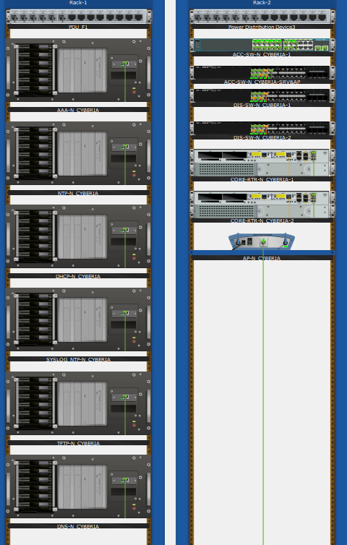

**Second Floor**

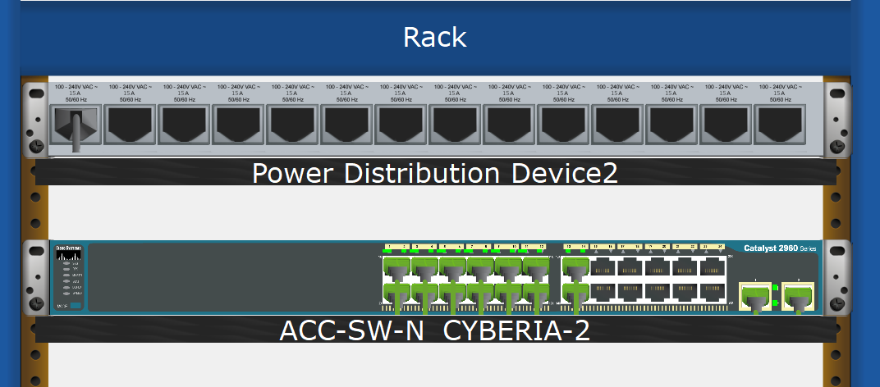

**Third Floor**

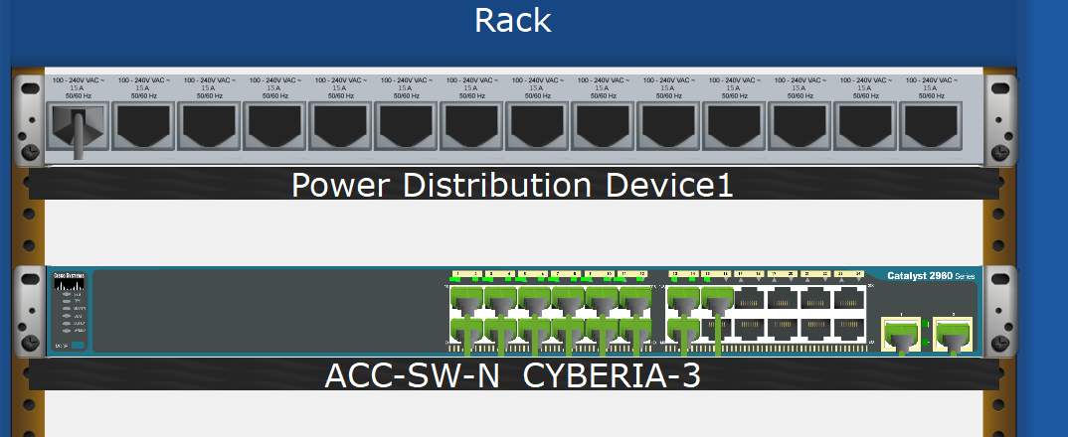

### ISP Pops

**TechVista**

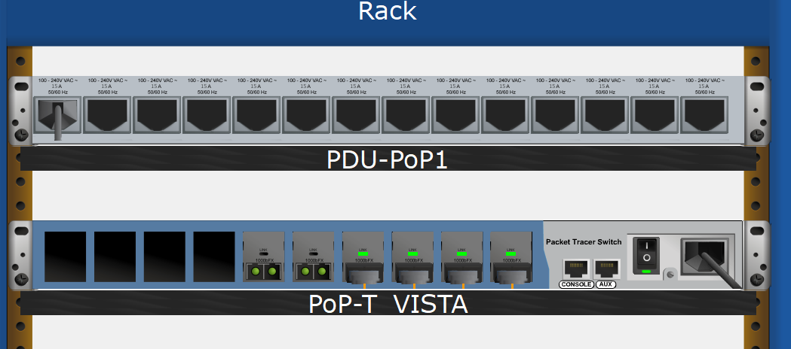

**CodePort**

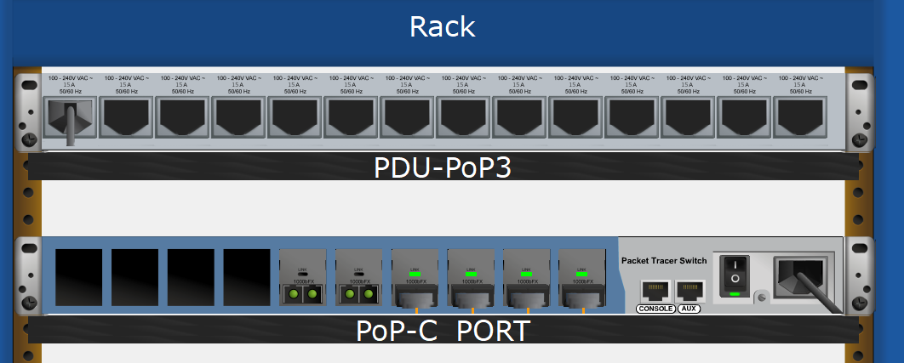

**NeoCyberia**

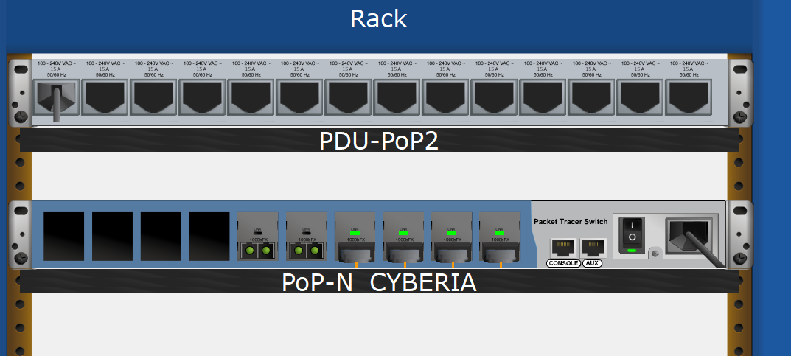

**Remote Worker**

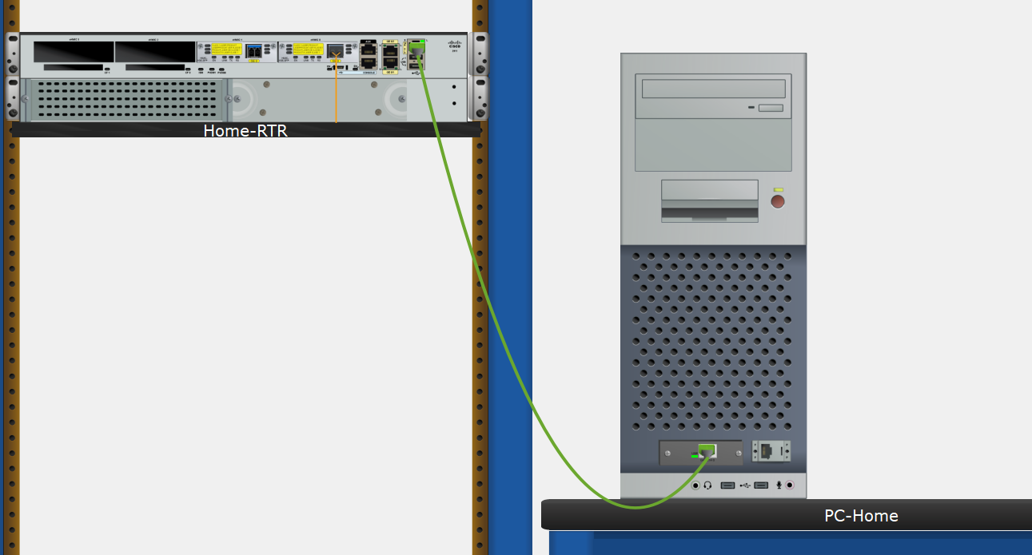

## Logical Topology View

### Core Network

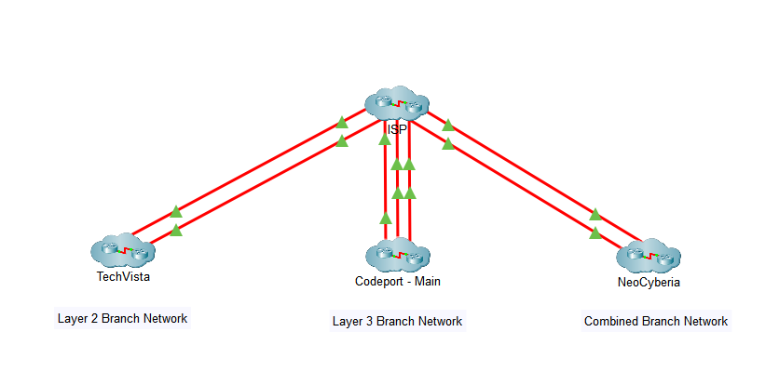

### TechVista Branch

**Network Infrastructure**

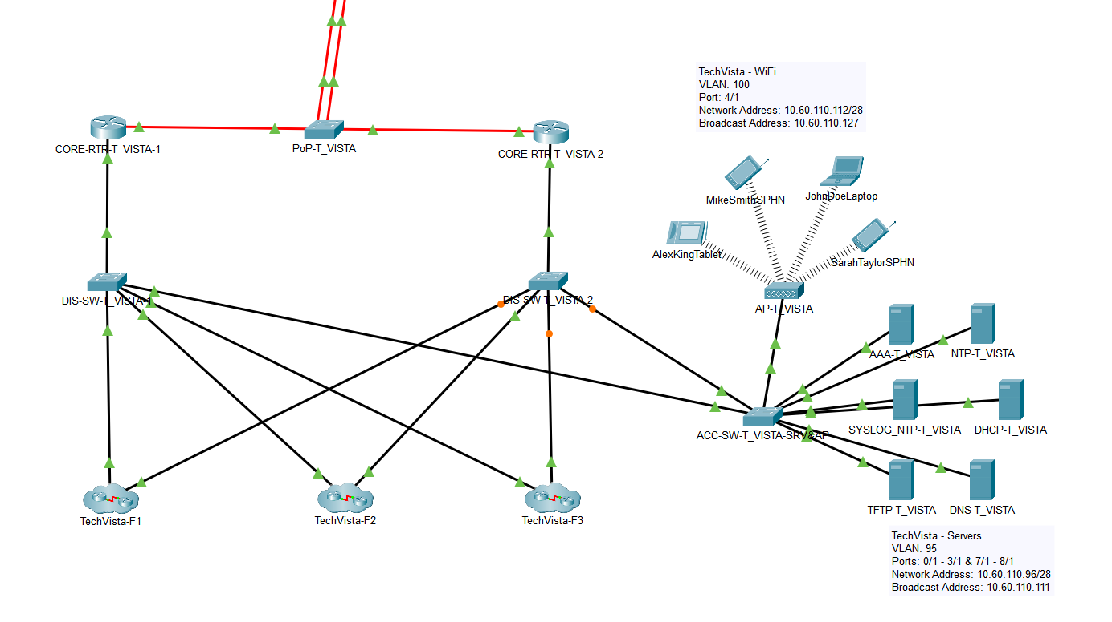

**First Floor**

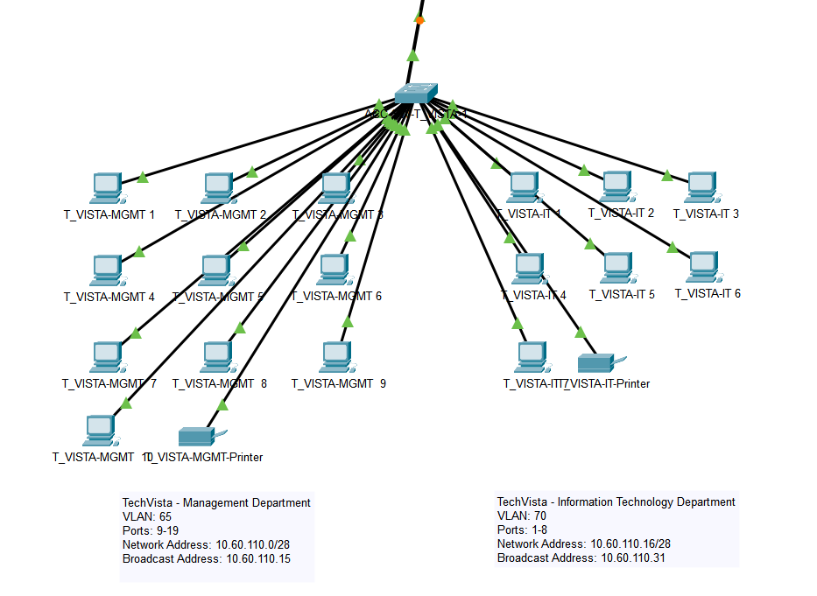

**Second Floor**

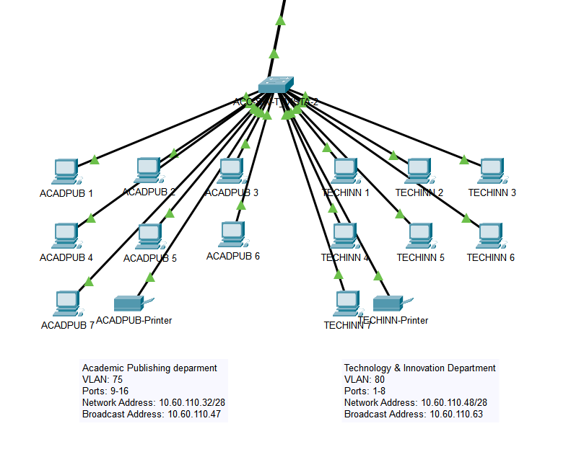

**Third Floor**

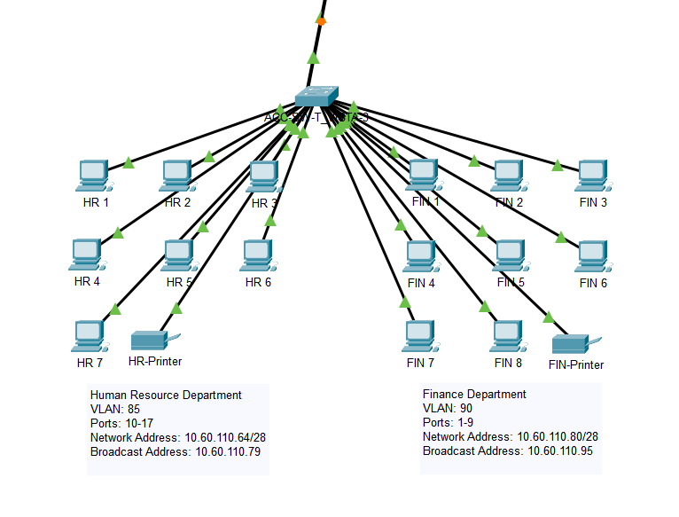

### CodePort Branch

**Network Infrastructure**

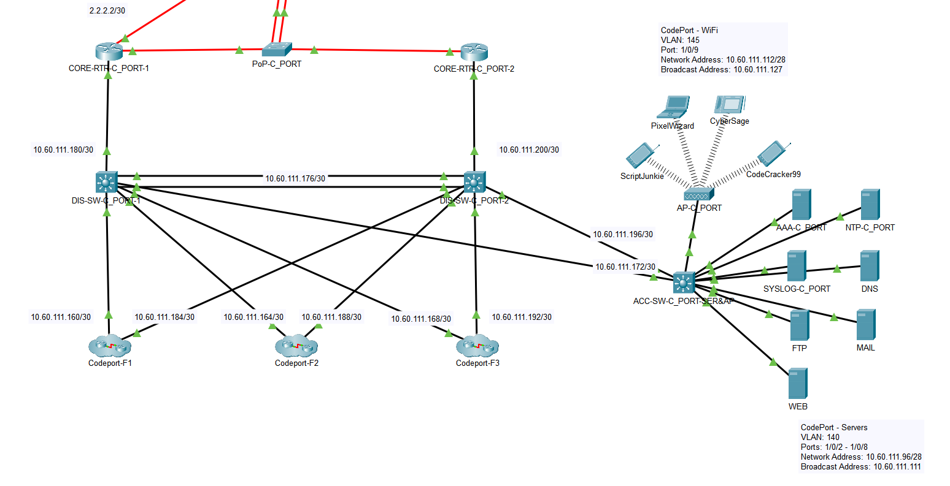

**First Floor**

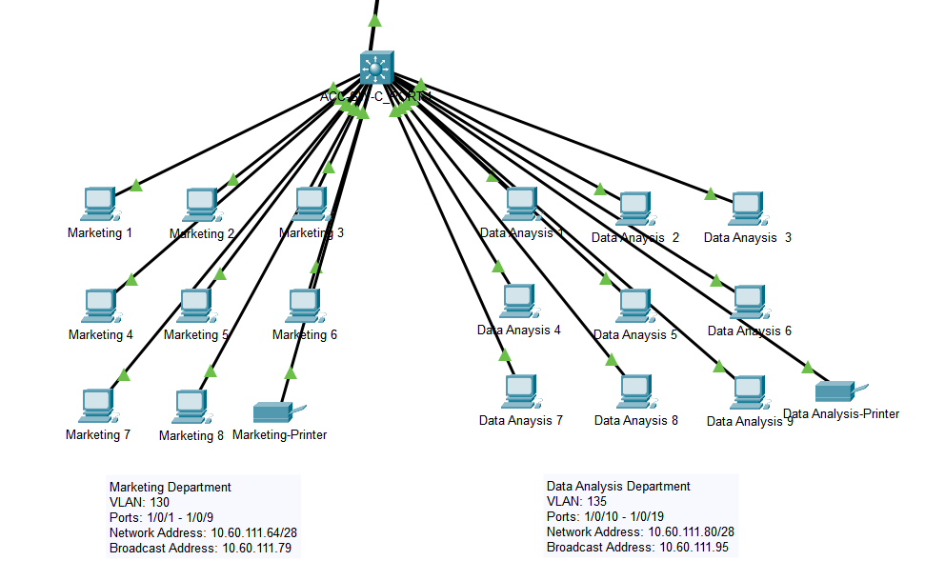

**Second Floor**

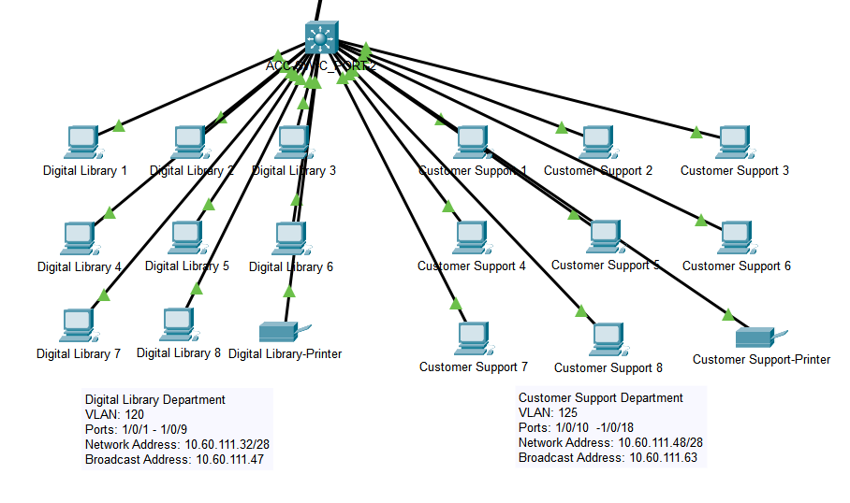

**Third Floor**

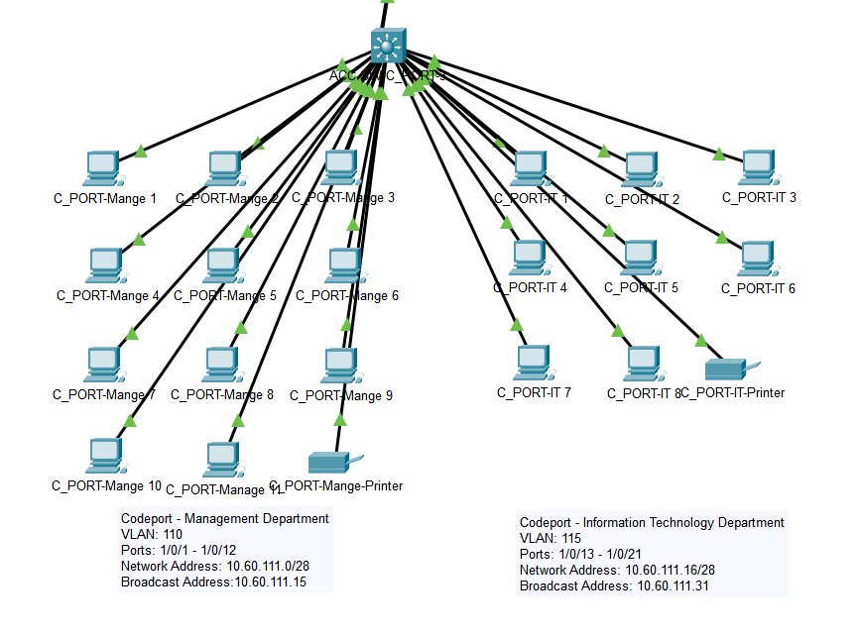

### NeoCyberia Branch

**Network Infrastructure**

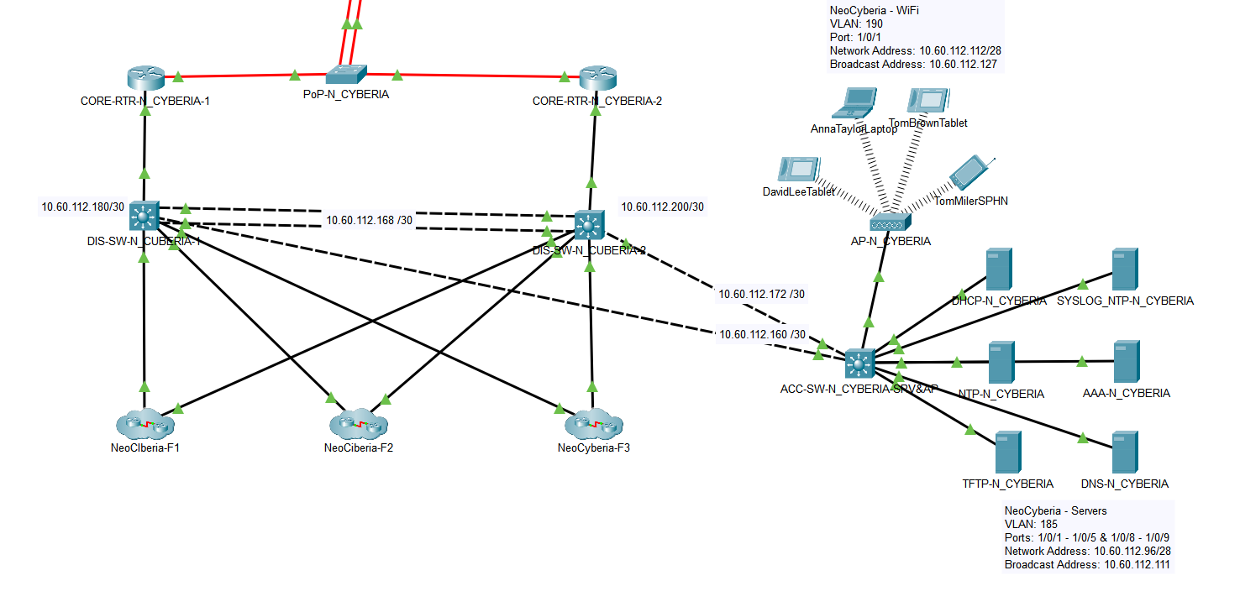

**First Floor**

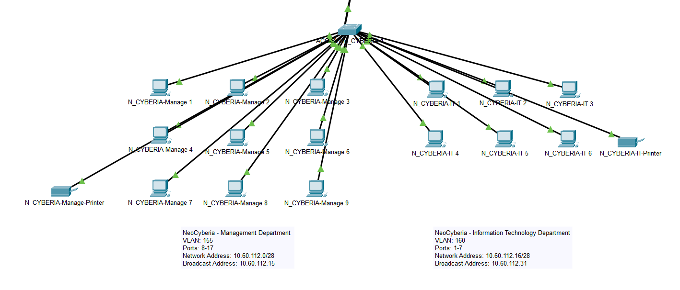

**Second Floor**

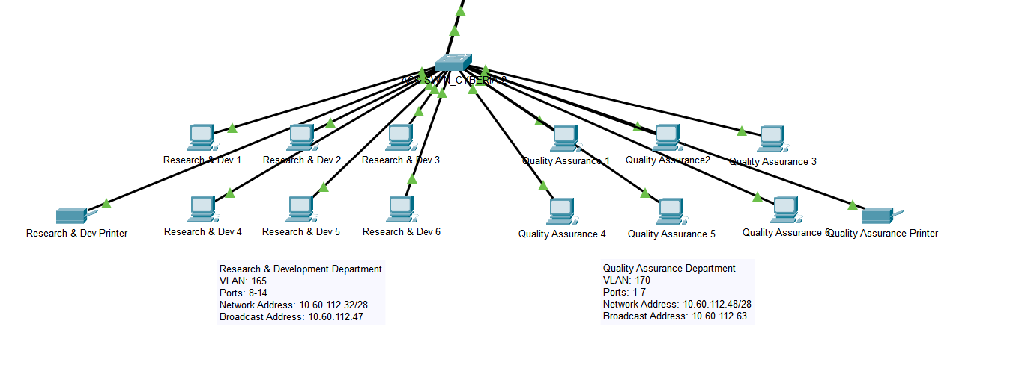

**Third Floor**

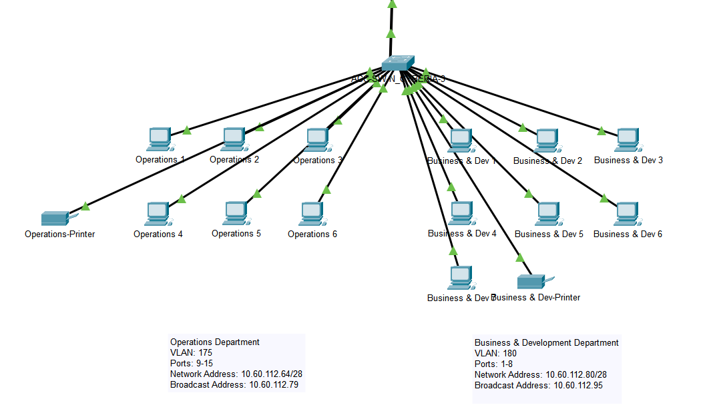

### ISPs

**Company-ISP**

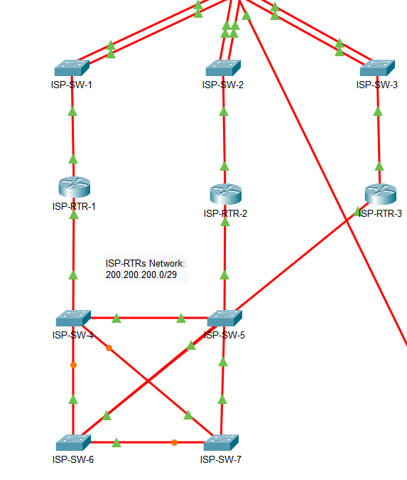

**ISP-Partner**

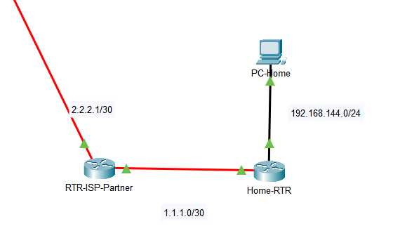

# 

# Network Infrastructure and IP Allocation

## TechVista Branch

**VLAN Routing Allocation Table**

|  |  |  |  |  |  |  |
| --- | --- | --- | --- | --- | --- | --- |
| **Department/Zone Name** | **VLAN Number** | **VLAN Name** | **Network Address** | **Active Router** | **Standby Router** | **Default Gateway** |
| **Management** | 65 | TVISTA_MGMT | 10.60.110.0/28 | 10.60.110.12 | 10.60.110.13 | 10.60.110.14 |
| **Information Technology** | 70 | TVISTA_IT | 10.60.110.16/28 | 10.60.110.28 | 10.60.110.29 | 10.60.110.30 |
| **Academic Publishing** | 75 | ACADPUB | 10.60.110.32/28 | 10.60.110.44 | 10.60.110.45 | 10.60.110.46 |
| **Technology & Innovation** | 80 | TECHINN | 10.60.110.48/28 | 10.60.110.60 | 10.60.110.61 | 10.60.110.62 |
| **Human Resource** | 85 | HR | 10.60.110.64/28 | 10.60.110.76 | 10.60.110.77 | 10.60.110.78 |
| **Finance** | 90 | FIN | 10.60.110.80/28 | 10.60.110.92 | 10.60.110.93 | 10.60.110.94 |
| **Servers** | 95 | TVISTA_SRV | 10.60.110.96/28 | 10.60.110.108 | 10.60.110.109 | 10.60.110.110 |
| **AP** | 100 | TVISTA_AP | 10.60.110.112/28 | 10.60.110.124 | 10.60.110.125 | 10.60.110.126 |
| **Net Conf** | 105 | TVISTA_NETCONF | 10.60.110.128/28 | 10.60.110.140 | 10.60.110.141 | 10.60.110.142 |

## 

## Codeport Branch – Main

**VLAN Routing Allocation Table**

|  |  |  |  |  |
| --- | --- | --- | --- | --- |
| Department/Zone Name | VLAN Number | VLAN Name | Network Address | Default Gateway |
| Management | 110 | CPORT_MGMT | 10.60.111.0/28 | 10.60.111.14 |
| Information Technology | 115 | CPORT_IT | 10.60.111.16/28 | 10.60.111.30 |
| Digital Library | 120 | DIGLIB | 10.60.111.32/28 | 10.60.111.46 |
| Customer Support | 125 | CUSTSUP | 10.60.111.48/28 | 10.60.111.62 |
| Marketing | 130 | MKTG | 10.60.111.64/28 | 10.60.111.78 |
| Data Analysis | 135 | DATAAN | 10.60.111.80/28 | 10.60.111.94 |
| Servers | 140 | CPORT_SRV | 10.60.111.96/28 | 10.60.111.110 |
| AP | 145 | CPORT_AP | 10.60.111.112/28 | 10.60.111.126 |

**Inter-Device IP Allocation Table**

|  |  |  |  |  |
| --- | --- | --- | --- | --- |
| Network Device (ND) 1 | Network Device (ND) 2 | Network | IP Add - ND 1 | IP Add – ND 2 |
| DIS-SW-C_PORT-1 | ACC-SW-C_PORT-1 | 10.60.111.160/30 | 10.60.111.161 | 10.60.111.162 |
| DIS-SW-C_PORT-1 | ACC-SW-C_PORT-2 | 10.60.111.164/30 | 10.60.111.165 | 10.60.111.166 |
| DIS-SW-C_PORT-1 | ACC-SW-C_PORT-3 | 10.60.111.168/30 | 10.60.111.169 | 10.60.111.170 |
| DIS-SW-C_PORT-1 | ACC-SW-C_PORT-SRV&AP | 10.60.111.172/30 | 10.60.111.173 | 10.60.111.174 |
| DIS-SW-C_PORT-1 | *DIS-SW-C_PORT-2: EthCha* | 10.60.111.176/30 | 10.60.111.177 | 10.60.111.178 |
| DIS-SW-C_PORT-1 | CORE-RTR -C_PORT-1 | 10.60.111.180/30 | 10.60.111.181 | 10.60.111.182 |
| DIS-SW-C_PORT-2 | ACC-SW-C_PORT-1 | 10.60.111.184/30 | 10.60.111.185 | 10.60.111.186 |
| DIS-SW-C_PORT-2 | ACC-SW-C_PORT-2 | 10.60.111.188/30 | 10.60.111.189 | 10.60.111.190 |
| DIS-SW-C_PORT-2 | ACC-SW-C_PORT-3 | 10.60.111.192/30 | 10.60.111.193 | 10.60.111.194 |
| DIS-SW-C_PORT-2 | ACC-SW-C_PORT-SRV&AP | 10.60.111.196/30 | 10.60.111.197 | 10.60.111.198 |
| DIS-SW-C_PORT-2 | *DIS-SW-C_PORT-1: EthCha* | 10.60.111.176/30 | 10.60.111.178 | 10.60.111.177 |
| DIS-SW-C_PORT-2 | CORE-RTR -C_PORT-2 | 10.60.111.200/30 | 10.60.111.201 | 10.60.111.202 |

## NeoCyberia Branch

#### VLAN Routing Allocation Table

|  |  |  |  |  |  |  |
| --- | --- | --- | --- | --- | --- | --- |
| Department/Zone Name | VLAN Number | VLAN Name | Network Address | Active Router | Standby Router | Default Gateway |
| Management | 155 | NCYBERIA_MGMT | 10.60.112.0/28 | 10.60.112.12 | 10.60.112.13 | 10.60.112.14 |
| Information Technology | 160 | NCYBERIA_IT | 10.60.112.16/28 | 10.60.112.28 | 10.60.112.29 | 10.60.112.30 |
| Research & Development | 165 | RESDEV | 10.60.112.32/28 | 10.60.112.44 | 10.60.112.45 | 10.60.112.46 |
| Quality Assurance | 170 | QA | 10.60.112.48/28 | 10.60.112.60 | 10.60.112.61 | 10.60.112.62 |
| Operations | 175 | OPS | 10.60.112.64/28 | 10.60.112.76 | 10.60.112.77 | 10.60.112.78 |
| Business Development | 180 | BIZDEV | 10.60.112.80/28 | 10.60.112.92 | 10.60.112.93 | 10.60.112.94 |
| Servers | 185 | NCYBERIA_SRV | 10.60.112.96/28 | 10.60.112.108 | 10.60.112.109 | 10.60.112.110 |
| AP | 190 | NCYBERIA_AP | 10.60.112.112/28 | 10.60.112.124 | 10.60.112.125 | 10.60.112.126 |
| Net Conf | 195 | NCYBERIA_NETCONF | 10.60.112.128/28 | 10.60.112.140 | 10.60.112.141 | 10.60.112.142 |

#### Inter-Device IP Allocation Table

|  |  |  |  |  |
| --- | --- | --- | --- | --- |
| Network Device (ND) 1 | Network Device (ND) 2 | Network | IP Add - ND 1 | IP Add – ND 2 |
| DIS-SW-N_CYBERIA-1 | ACC-SW-N_CYBERIA-SRV&AP | 10.60.112.160/30 | 10.60.112.161 | 10.60.112.162 |
| DIS-SW-N_CYBERIA-2 | ACC-SW-N_CYBERIA-SRV&AP | 10.60.112.172/30 | 10.60.112.173 | 10.60.112.174 |
| DIS-SW-N_CYBERIA-1 | DIS-SW-N_CYBERIA-2 : EthCha | 10.60.112.168/30 | 10.60.112.169 | 10.60.112.170 |
| DIS-SW-N_CYBERIA-2 | DIS-SW-N_CYBERIA-1 : EthCha | 10.60.112.168/30 | 10.60.112.170 | 10.60.112.169 |
| DIS-SW-N_CYBERIA-1 | CORE-RTR-N_CYBERIA-1 | 10.60.112.180/30 | 10.60.112.181 | 10.60.112.182 |
| DIS-SW-N_CYBERIA-2 | CORE-RTR-N_CYBERIA-2 | 10.60.112.200/30 | 10.60.112.201 | 10.60.112.202 |

**­**

# Equipment Inventory and Access Credentials

## TechVista Branch

**Equipment Details Table**

|  |  |  |  |
| --- | --- | --- | --- |
| **Hostname** | **Model** | **Management IP Address** | **Physical Location** |
| ACC-SW-T_VISTA-1 | 2960 IOS15 | 10.60.110.129 | TechVista-F1-Closet |
| ACC-SW-T_VISTA-2 | 2960 IOS15 | 10.60.110.130 | TechVista-F2-Closet |
| ACC-SW-T_VISTA-3 | 2960 IOS15 | 10.60.110.131 | TechVista-F3-Closet |
| ACC-SW-T_VISTA-SRV&AP | Empty-PT | 10.60.110.132 | TechVista-F1-Closet |
| DIS-SW-T_VISTA-1 | Empty-Pt | 10.60.110.133 | TechVista-F1-Closet |
| DIS-SW-T_VISTA-2 | Empty-Pt | 10.60.110.134 | TechVista-F1-Closet |
| CORE-RTR-T_VISTA-1 | 2911 | 10.60.110.109 | TechVista-F1-Closet |
| CORE-RTR-T_VISTA-2 | 2911 | 10.60.110.110 | TechVista-F1-Closet |

**Equipment Access Credentials Table**

|  |  |  |  |
| --- | --- | --- | --- |
| **Hostname** | **Enable Password** | **Enable Secret** | **VTY Password** |
| ACC-SW-T_VISTA-1 | 110PASSWORD | 110SECRET | AAA Authentication |
| ACC-SW-T_VISTA-2 | 110PASSWORD | 110SECRET | AAA Authentication |
| ACC-SW-T_VISTA-3 | 110PASSWORD | 110SECRET | AAA Authentication |
| ACC-SW-T_VISTA-SRV&AP | 110PASSWORD | 110SECRET | Login |
| DIS-SW-T_VISTA-1 | 110PASSWORD | 110SECRET | Login |
| DIS-SW-T_VISTA-2 | 110PASSWORD | 110SECRET | Login |
| CORE-RTR-T_VISTA-1 | 110PASSWORD | 110SECRET | AAA Authentication |
| CORE-RTR-T_VISTA-2 | 110PASSWORD | 110SECRET | AAA Authentication |

## Codeport Branch - Main

**Equipment Details Table**

|  |  |  |  |
| --- | --- | --- | --- |
| **Hostname** | **Model** | **Management IP Address** | **Physical Location** |
| ACC-SW-C_PORT-1 | 3650-24PS | 10.60.111.129 | Codeport-F1-Closet |
| ACC-SW-C_PORT-2 | 3650-24PS | 10.60.111.130 | Codeport-F2-Closet |
| ACC-SW-C_PORT-3 | 3650-24PS | 10.60.111.131 | Codeport-F3-Closet |
| ACC-SW-C_PORT-SRV&AP | 3650-24PS | 10.60.111.132 | Codeport-F1-Closet |
| DIS-SW-C_PORT-1 | 3650-24PS | 10.60.111.133 | Codeport-F1-Closet |
| DIS-SW-C_PORT-2 | 3650-24PS | 10.60.111.134 | Codeport-F1-Closet |
| CORE-RTR-C_PORT-1 | 2911 | 10.60.111.135 | Codeport-F1-Closet |
| CORE-RTR-C_PORT-2 | 2911 | 10.60.111.136 | Codeport-F1-Closet |

**Equipment Access Credentials Table**

|  |  |  |  |
| --- | --- | --- | --- |
| **Hostname** | **Enable Password** | **Enable Secret** | **VTY Password** |
| ACC-SW-C_PORT-1 | 111SPASSWORD | 111SECRET | AAA Authentication |
| ACC-SW-C_PORT-2 | 111SPASSWORD | 111SECRET | AAA Authentication |
| ACC-SW-C_PORT-3 | 111SPASSWORD | 111SECRET | AAA Authentication |
| ACC-SW-C_PORT-SRV&AP | 111SPASSWORD | 111SECRET | AAA Authentication |
| DIS-SW-C_PORT-1 | 111SPASSWORD | 111SECRET | AAA Authentication |
| DIS-SW-C_PORT-2 | 111SPASSWORD | 111SECRET | AAA Authentication |
| CORE-RTR-C_PORT-1 | 111SPASSWORD | 111SECRET | AAA Authentication |
| CORE-RTR-C_PORT-2 | 111SPASSWORD | 111SECRET | AAA Authentication |

## NeoCyberia Branch

**Equipment Details Table**

|  |  |  |  |
| --- | --- | --- | --- |
| **Hostname** | **Model** | **Management IP Address** | **Physical Location** |
| ACC-SW-N_CYBERIA-1 | 2960 IOS15 | 10.60.112.129 | NeoCyberia-F1-Closet |
| ACC-SW-N_CYBERIA-2 | 2960 IOS15 | 10.60.112.130 | NeoCyberia-F2-Closet |
| ACC-SW-N_CYBERIA-3 | 2960 IOS15 | 10.60.112.131 | NeoCyberia-F3-Closet |
| ACC-SW-N_CYBERIA-SRV&AP | 3650-24PS | 10.60.112.132 | NeoCyberia-F1-Closet |
| DIS-SW-N_CYBERIA-1 | 3650-24PS | 10.60.112.133 | NeoCyberia-F1-Closet |
| DIS-SW-N_CYBERIA-2 | 3650-24PS | 10.60.112.134 | NeoCyberia-F1-Closet |
| CORE-RTR-N_CYBERIA-1 | 2911 | 10.60.112.135 | NeoCyberia-F1-Closet |
| CORE-RTR-N_CYBERIA-2 | 2911 | 10.60.112.136 | NeoCyberia-F1-Closet |

**Equipment Access Credentials Table**

|  |  |  |  |
| --- | --- | --- | --- |
| **Hostname** | **Enable Password** | **Enable Secret** | **VTY Password** |
| ACC-SW-N_CYBERIA-1 | 112PASSWORD | 112SECRET | AAA Authentication |
| ACC-SW-N_CYBERIA-2 | 112PASSWORD | 112SECRET | AAA Authentication |
| ACC-SW-N_CYBERIA-3 | 112PASSWORD | 112SECRET | AAA Authentication |
| ACC-SW-N_CYBERIA-SRV&AP | 112PASSWORD | 112SECRET | AAA Authentication |
| DIS-SW-N_CYBERIA-1 | 112PASSWORD | 112SECRET | AAA Authentication |
| DIS-SW-N_CYBERIA-2 | 112PASSWORD | 112SECRET | AAA Authentication |
| CORE-RTR-N_CYBERIA-1 | 112PASSWORD | 112SECRET | AAA Authentication |
| CORE-RTR-N_CYBERIA-2 | 112PASSWORD | 112SECRET | AAA Authentication |

# Servers Config and Domain Mappings

## TechVista Branch

|  |  |  |
| --- | --- | --- |
| **Server** | **Address** | **Domain** |
| AAA | 10.60.110.97 | aaa.techvista.mentoranexus.com |
| NTP | 10.60.110.98 | ntp.techvista.mentoranexus.com |
| SYSLOG_NTP | 10.60.110.99 | syslog.techvista.mentoranexus.com |
| DHCP | 10.60.110.100 | N/A |
| TFTP | 10.60.110.101 | tftp.techvista.mentoranexus.com |
| DNS | 10.60.110.102 | N/A |

## Codeport Branch - Main

|  |  |  |
| --- | --- | --- |
| **Server** | **Address** | **Domain** |
| AAA | 10.60.111.97 | aaa.mentoranexus.com |
| NTP | 10.60.111.98 | ntp.mentoranexus.com |
| SYSLOG | 10.60.111.99 | syslog.mentoranexus.com |
| DNS | 10.60.111.100 | N/A |
| FTP | 10.60.111.101 | ftp.mentoranexus.com |
| MAIL | 10.60.111.102 | mail.mentoranexus.com |
| WEB (HTTP) | 10.60.111.103 | mentoranexus.com |

## NeoCyberia Branch

|  |  |  |
| --- | --- | --- |
| **Server** | **Address** | **Domain** |
| DHCP | 10.60.112.97 | N/A |
| SYSLOG_NTP | 10.60.112.98 | syslog.neocyberia.mentoranexus.com |
| NTP | 10.60.112.99 | ntp.neocyberia.mentoranexus.com |
| AAA | 10.60.112.100 | aaa.neocyberia.mentoranexus.com |
| TFTP | 10.60.112.101 | tftp.neocyberia.mentoranexus.com |
| DNS | 10.60.112.102 | N/A |

­­

# AAA Tables

## TechVista Branch

|  |  |  |  |
| --- | --- | --- | --- |
| **Hostname** | **Host Address** | **Key** | **Server Type** |
| ACC-SW-T_VISTA-1 | 10.60.110.129 | 110TACACS | Tacacs |
| ACC-SW-T_VISTA-2 | 10.60.110.130 | 110TACACS | Tacacs |
| ACC-SW-T_VISTA-3 | 10.60.110.131 | 110TACACS | Tacacs |
| ACC-SW-T_VISTA-SRV&AP | 10.60.110.132 | Not Supported | Not Supported |
| DIS-SW-T_VISTA-1 | 10.60.110.133 | Not Supported | Not Supported |
| DIS-SW-T_VISTA-2 | 10.60.110.134 | Not Supported | Not Supported |
| CORE-RTR-T_VISTA-1 | 10.60.110.109 | 110TACACS | Tacacs |
| CORE-RTR-T_VISTA-2 | 10.60.110.110 | 110TACACS | Tacacs |

## Codeport Branch - Main

|  |  |  |  |
| --- | --- | --- | --- |
| **Hostname** | **Host Address** | **Key** | **Server Type** |
| ACC-SW-C_PORT-1 | 10.60.111.186 | 111TACACS | Tacacs |
| ACC-SW-C_PORT-2 | 10.60.111.190 | 111TACACS | Tacacs |
| ACC-SW-C_PORT-3 | 10.60.111.194 | 111TACACS | Tacacs |
| ACC-SW-C_PORT-SRV&AP | 10.60.111.198 | 111TACACS | Tacacs |
| DIS-SW-C_PORT-1 | 10.60.111.173 | 111TACACS | Tacacs |
| DIS-SW-C_PORT-2 | 10.60.111.197 | 111TACACS | Tacacs |
| CORE-RTR-C_PORT-1 | 10.60.111.182 | 111TACACS | Tacacs |
| CORE-RTR-C_PORT-2 | 10.60.111.202 | 111TACACS | Tacacs |

## NeoCyberia Branch

|  |  |  |  |
| --- | --- | --- | --- |
| **Hostname** | **Host Address** | **Key** | **Server Type** |
| ACC-SW-N_CYBERIA -1 | 10.60.112.129 | 112TACACS | Tacacs |
| ACC-SW-N_CYBERIA -2 | 10.60.112.130 | 112TACACS | Tacacs |
| ACC-SW-N_CYBERIA -3 | 10.60.112.131 | 112TACACS | Tacacs |
| ACC-SW-N_CYBERIA-SRV&AP | 10.60.112.110 | 112TACACS | Tacacs |
| DIS-SW-N_CYBERIA -1 | 10.60.112.161 | 112TACACS | Tacacs |
| DIS-SW-N_CYBERIA -2 | 10.60.112.173 | 112TACACS | Tacacs |
| CORE-RTR-N_CYBERIA-1 | 10.60.112.182 | 112TACACS | Tacacs |
| CORE-RTR-N_CYBERIA-2 | 10.60.112.202 | 112TACACS | Tacacs |

# VTP Tables

## TechVista Branch

|  |  |  |  |
| --- | --- | --- | --- |
| **Hostname** | **Role** | **Domain-Name** | **Password** |
| ACC-SW-T_VISTA-1 | client | mentoranexus.com | vtp1234 |
| ACC-SW-T_VISTA-2 | client | mentoranexus.com | vtp1234 |
| ACC-SW-T_VISTA-3 | client | mentoranexus.com | vtp1234 |
| ACC-SW-T_VISTA-SRV&AP | client | mentoranexus.com | vtp1234 |
| DIS-SW-T_VISTA-1 | server | mentoranexus.com | vtp1234 |
| DIS-SW-T_VISTA-2 | server | mentoranexus.com | vtp1234 |

## NeoCyberia Branch

|  |  |  |  |
| --- | --- | --- | --- |
| **Hostname** | **Role** | **Domain-Name** | **Password** |
| ACC-SW-N_CYBERIA -1 | client | mentoranexus.com | vtp1234 |
| ACC-SW- N_CYBERIA -2 | client | mentoranexus.com | vtp1234 |
| ACC-SW- N_CYBERIA -3 | client | mentoranexus.com | vtp1234 |
| ACC-SW- N_CYBERIA -SRV&AP | client | mentoranexus.com | vtp1234 |
| DIS-SW- N_CYBERIA -1 | server | mentoranexus.com | vtp1234 |
| DIS-SW- N_CYBERIA -2 | server | mentoranexus.com | vtp1234 |

# AP Tables

|  |  |  |
| --- | --- | --- |
| **Hostname** | **SSID** | **Password** |
| AP-T_VISTA | TechVistaWiFi | 110WIFIPASS |
| AP-C_PORT | CodePortWIFi | 111WIFIPASS |
| AP-N_CYBERIA | NeoCyberiaWiFi | 112WIFIPASS |

# Mail Tables

**Domain Name -** *mail.mentoranexus.com*

## TechVista Branch

|  |  |  |  |
| --- | --- | --- | --- |
| **User Name** | **Password** | **Department** | **Hostname** |
| Alexander | AlexanderMail1234 | Management | T_VISTA-MGMT 1 |
| Andrew | AndrewMail1234 | IT | T_VISTA-IT 1 |
| Anthony | AnthonyMail1234 | Academic Publishing | ACADPUB 1 |
| Brian | BrianMail1234 | Technology & Innovation | TECHINN 1 |
| Daniel | DanielMail1234 | HR | HR 1 |
| Amy | AmyMail1234 | Finance | FIN 1 |

|  |  |
| --- | --- |
| **Employee Name** | **Official Email Address** |
| Alexander Carter | alexander@mail.mentoranexus.com |
| Andrew Mitchell | andrew@mail.mentoranexus.com |
| Anthony Roberts | anthony@mail.mentoranexus.com |
| Brian Thompson | brian@mail.mentoranexus.com |
| Daniel Harrison | daniel@mail.mentoranexus.com |
| Amy Richardton | amy@mail.mentoranexus.com |

## CodePort Branch

|  |  |  |  |
| --- | --- | --- | --- |
| **User Name** | **Password** | **Department** | **Hostname** |
| Betty | BettyMail1234 | Management | C_PORT-Manage 1 |
| Carol | CarolMail1234 | IT | C_PORT_IT 1 |
| Emma | EmmaMail1234 | Digital Library | Digital Library 1 |
| Lisa | LisaMail1234 | Customer Support | Customer Support 1 |
| Mark | MarkMail1234 | Marketing | Marketing 1 |
| Paul | PaulMail1234 | Data Analysis | Data Analysis 1 |

|  |  |
| --- | --- |
| **Employee Name** | **Official Email Address** |
| Betty Colins | betty@mail.mentoranexus.com |
| Carol Simmons | carol@mail.mentoranexus.com |
| Emma Wright | emma@mail.mentoranexus.com |
| Lisa Andreson | lisa@mail.mentoranexus.com |
| Mark Bennett | mark@mail.mentoranexus.com |
| Paul Reynolds | paul@mail.mentoranexus.com |

## NeoCyberia Branch

|  |  |  |  |
| --- | --- | --- | --- |
| **User Name** | **Password** | **Department** | **Hostname** |
| Robert | RobertMail1234 | Management | N_CYBERIA-Manage 1 |
| Ryan | RyanMail1234 | IT | N_CYBERIA-IT 1 |
| Scott | ScottMail1234 | Research & Dev | Research & Dev 1 |
| Steven | StevenMail1234 | Quality Assurance | Quality Assurance 1 |
| Thomas | ThomasMail1234 | Operations | Operations 1 |
| Jose | JoseMail1234 | Business Development | Business & Dev 1 |

|  |  |
| --- | --- |
| **Employee Name** | **Official Email Address** |
| Robert Phillips | robert@mail.mentoranexus.com |
| Ryan Edwards | ryan@mail.mentoranexus.com |
| Scott Douglas | scott@mail.mentoranexus.com |
| Steven Foster | steven@mail.mentoranexus.com |
| Thomas Griffin | thomas@mail.mentoranexus.com |
| Jose Martinez | jose@mail.mentoranexus.com |

# BGP Peer and ISP Network Topology

## BGP Peer Relationships Table

|  |  |  |  |  |
| --- | --- | --- | --- | --- |
| **Network Subnet** | **ASN** | **IP Address** | **Neighbor IP Addresses** | **Neighbor ASNs** |
| 200.200.200.0/29 | 10 | 200.200.200.1 | 200.200.200.2 | 20 |
| 200.200.200.3 | 30 |
| 20 | 200.200.200.2 | 200.200.200.1 | 10 |
| 200.200.200.3 | 30 |
| 30 | 200.200.200.3 | 200.200.200.1 | 10 |
| 200.200.200.2 | 20 |

## Branch ISP Connectivity and IP Allocation

|  |  |  |  |
| --- | --- | --- | --- |
| **Config Parameter** | **TechVista Site** | **CodePort Site** | **NeoCyberia Site** |
| **Subnet** | 110.110.110.0/29 | 111.111.111.0/29 | 112.112.112.0/29 |
| **ISP Router ASN** | 10 | 20 | 30 |
| **Core Router 1** | CORE-RTR-T_VISTA-1 | CORE-RTR-C_PORT-1 | CORE-RTR-N_CYBERIA-1 |
| **Core Router 2** | CORE-RTR-T_VISTA-2 | CORE-RTR-C_PORT-2 | CORE-RTR-N_CYBERIA-2 |
| **ISP Router** | ISP-RTR-1 | ISP-RTR-2 | ISP-RTR-3 |
| **Allocated IP 1** | .1 | .1 | .1 |
| **Allocated IP 2** | .2 | .2 | .2 |
| **Allocated IP 3** | .3 | .3 | .3 |

# Secure Tunneling and Endpoint Configuration

## TechVista

**Tunnel Endpoint Router and Public Interface Config**

|  |  |  |  |  |
| --- | --- | --- | --- | --- |
| **Tunnel ID** | **Source Router** | **Destination Router** | **Source Interface / IP Address** | **Destination IP Address** |
| 11011101 | CORE-RTR-T_VISTA-1 | CORE-RTR-C_PORT-1 | G0/0/0  110.110.110.1 | 111.111.111.1 |
| 11011201 | CORE-RTR-T_VISTA-1 | CORE-RTR-N_CYBERIA-1 | G0/0/0  110.110.110.1 | 112.112.112.1 |
| 11011102 | CORE-RTR-T_VISTA-2 | CORE-RTR-C_PORT-2 | G0/0/0  110.110.110.2 | 111.111.111.2 |
| 11011202 | CORE-RTR-T_VISTA-2 | CORE-RTR-N_CYBERIA-2 | G0/0/0  110.110.110.2 | 112.112.112.2 |

**Tunnel ID and Subnet Assignment**

|  |  |  |  |
| --- | --- | --- | --- |
| **Tunnel ID** | **IP Subnet** | **Local Tunnel Endpoint** | **Remote Tunnel Endpoint** |
| 11011101 | 192.168.1.0/30 | 192.168.1.1 | 192.168.1.2 |
| 11011201 | 192.168.1.4/30 | 192.168.1.5 | 192.168.1.6 |
| 11011102 | 192.168.1.8/30 | 192.168.1.9 | 192.168.1.10 |
| 11011202 | 192.168.1.12/30 | 192.168.1.13 | 192.168.1.14 |

## CodePort

**Tunnel Endpoint Router and Public Interface Config**

|  |  |  |  |  |
| --- | --- | --- | --- | --- |
| **Tunnel ID** | **Source Router** | **Destination Router** | **Source Interface / IP Address** | **Destination IP Address** |
| 11111001 | CORE-RTR-C_PORT-1 | CORE-RTR-T_VISTA-1 | G0/0/0  111.111.111.1 | 110.110.110.1 |
| 11111201 | CORE-RTR-C_PORT-1 | CORE-RTR-N_CYBERIA-1 | G0/0/0  111.111.111.1 | 112.112.112.1 |
| 11111002 | CORE-RTR-C_PORT-2 | CORE-RTR-T_VISTA-2 | G0/0/0  111.111.111.2 | 110.110.110.2 |
| 11111202 | CORE-RTR-C_PORT-2 | CORE-RTR-N_CYBERIA-2 | G0/0/0  111.111.111.2 | 112.112.112.2 |

**Tunnel ID and Subnet Assignment**

|  |  |  |  |
| --- | --- | --- | --- |
| **Tunnel ID** | **IP Subnet** | **Local Tunnel Endpoint** | **Remote Tunnel Endpoint** |
| 11111001 | 192.168.1.0/30 | 192.168.1.2 | 192.168.1.1 |
| 11111201 | 192.168.1.16/30 | 192.168.1.17 | 192.168.1.18 |
| 11111002 | 192.168.1.8/30 | 192.168.1.10 | 192.168.1.9 |
| 11111202 | 192.168.1.20/30 | 192.168.1.21 | 192.168.1.22 |

## NeoCyberia

**Tunnel Endpoint Router and Public Interface Config**

|  |  |  |  |  |
| --- | --- | --- | --- | --- |
| **Tunnel ID** | **Source Router** | **Destination Router** | **Source Interface / IP Address** | **Destination IP Address** |
| 11211001 | CORE-RTR-N_CYBERIA-1 | CORE-RTR-T_VISTA-1 | G0/0/0  112.112.112.1 | 110.110.110.1 |
| 11211101 | CORE-RTR-N_CYBERIA-1 | CORE-RTR-C_PORT-1 | G0/0/0  112.112.112.1 | 111.111.111.1 |
| 11211002 | CORE-RTR-N_CYBERIA-2 | CORE-RTR-T_VISTA-2 | G0/0/0  112.112.112.2 | 110.110.110.2 |
| 11211102 | CORE-RTR-N_CYBERIA-2 | CORE-RTR-C_PORT-2 | G0/0/0  112.112.112.2 | 111.111.111.2 |

**Tunnel ID and Subnet Assignment**

|  |  |  |  |
| --- | --- | --- | --- |
| **Tunnel ID** | **IP Subnet** | **Local Tunnel Endpoint** | **Remote Tunnel Endpoint** |
| 11211001 | 192.168.1.4/30 | 192.168.1.6 | 192.168.1.5 |
| 11211101 | 192.168.1.16/30 | 192.168.1.18 | 192.168.1.17 |
| 11211002 | 192.168.1.12/30 | 192.168.1.14 | 192.168.1.13 |
| 11211102 | 192.168.1.20/30 | 192.168.1.22 | 192.168.1.21 |

# IPSec VPN Device Configuration

## Phase 1: ISKAMP/IKE Configuration

*Defines encryption and hashing algorithms, authentication method, and key exchange parameters for establishing the secure tunnel*

|  |  |  |  |  |  |  |
| --- | --- | --- | --- | --- | --- | --- |
| **Device** | **Policy Number** | **Encryption** | **Hash** | **Authentication** | **DH Group** | **Lifetime** |
| CORE-RTR-T_VISTA-1 | 10 | aes 256 | sha | pre-share | 5 | 86400 |
| CORE-RTR-T_VISTA-2 | 10 | aes 256 | sha | pre-share | 5 | 86400 |
| CORE-RTR-C_PORT-1 | 10 | aes 256 | sha | pre-share | 5 | 86400 |
| CORE-RTR-C_PORT-2 | 10 | aes 256 | sha | pre-share | 5 | 86400 |
| CORE-RTR-N_CYBERIA-1 | 10 | aes 256 | sha | pre-share | 5 | 86400 |
| CORE-RTR-N_CYBERIA-2 | 10 | aes 256 | sha | pre-share | 5 | 86400 |
| CORE-RTR-T_VISTA-1 | 10 | aes 256 | sha | pre-share | 5 | 86400 |

## Phase 2: IPSec Configuration

*Defines IPSec Security Associations, transform sets, and access lists for encryption.*

*Note: the ISKAMP Key belongs to Phase 1 despite its present in this Phase 2 subsection.*

|  |  |  |  |
| --- | --- | --- | --- |
| **Device** | **ISAKMP Key** | **Peers** | **Transform Set Name** |
| CORE-RTR-T_VISTA-1 | MentoraKey | 111.111.111.1, 112.112.112.1 | [T_V1=>C_P1,N_C1]_SET |
| CORE-RTR-T_VISTA-2 | MentoraKey | 111.111.111.2, 112.112.112.2 | [T_V2=>C_P2,N_C2]_SET |
| CORE-RTR-C_PORT-1 | MentoraKey | 110.110.110.1, 112.112.112.1 | [C_P1=>T_V1,N_C1]_SET |
| CORE-RTR-C_PORT-2 | MentoraKey | 110.110.110.2, 112.112.112.2 | [C_P2=>T_V2,N_C2]_SET |
| CORE-RTR-N_CYBERIA-1 | MentoraKey | 110.110.110.1, 111.111.111.1 | [N_C1=>T_V1,C_P1]_SET |
| CORE-RTR-N_CYBERIA-2 | MentoraKey | 110.110.110.2, 111.111.111.2 | [N_C2=>T_V2,C_P2]_SET |

|  |  |  |  |
| --- | --- | --- | --- |
| **Device** | **Access List Rules** | **Crypto Maps** | **Interface** |
| CORE-RTR-T_VISTA-1 | 10.60.110.0/24 -> 10.60.111.0/24, 10.60.110.0/24 -> 10.60.112.0/24 | [T_V1=>C_P1]_MAP 10, [T_V1=>N_C1]_MAP 20 | G0/0/0 |
| CORE-RTR-T_VISTA-2 | 10.60.110.0/24 -> 10.60.111.0/24, 10.60.110.0/24 -> 10.60.112.0/24 | [T_V2=>C_P2]_MAP 10, [T_V2=>N_C2]_MAP 20 | G0/0/0 |
| CORE-RTR-C_PORT-1 | 10.60.111.0/24 -> 10.60.110.0/24, 10.60.111.0/24 -> 10.60.112.0/24 | [C_P1=>T_V1]_MAP 10, [C_P1=>N_C1]_MAP 20 | G0/0/0 |
| CORE-RTR-C_PORT-2 | 10.60.111.0/24 -> 10.60.110.0/24, 10.60.111.0/24 -> 10.60.112.0/24 | [C_P2=>T_V2]_MAP 10, [C_P2=>N_C2]_MAP 20 | G0/0/0 |
| CORE-RTR-N_CYBERIA-1 | 10.60.112.0/24 -> 10.60.110.0/24, 10.60.112.0/24 -> 10.60.111.0/24 | [N_C1=>T_V1]_MAP 10, [N_C1=>C_P1]_MAP 20 | G0/0/0 |
| CORE-RTR-N_CYBERIA-2 | 10.60.112.0/24 -> 10.60.110.0/24, 10.60.112.0/24 -> 10.60.111.0/24 | [N_C2=>T_V2]_MAP 10, [N_C2=>C_P2]_MAP 20 | G0/0/0 |

# 

# Servers Configuration

## Domain Name System (DNS)

DNS translates human-readable **domain and host names** into **numeric IP addresses** using a **distributed, hierarchical structure** consisting of **root servers**, **top-level domain (TLD) servers**, and **authoritative name servers**. The resolution process involves **recursive queries** (handled by resolvers) and **iterative lookups** (performed by **DNS servers**). DNS supports **resource records** such as **A** (IPv4), **AAAA** (IPv6), **CNAME** (alias), **MX** (mail exchange), and **TXT** (arbitrary text storage).

Uses **UDP port 53** for standard queries**; TCP port 53** is used for large responses and zone transfers.

**IOS Commands Alongside Their Descriptions:**

|  |  |
| --- | --- |
| **Command** | **Description** |
| **[no] ip domain lookup** | [Disables] enables resolution of unknown issued strings by a remote DNS server |
| **ip name-server** *dns_server_ip_address* | Specifies the DNS server for performing the name resolutions. |

**Sample execution of specified commands**

CORE-RTR-T_VISTA-1(config)#ip domain lookup

CORE-RTR-T_VISTA-1(config)#ip name-server 10.60.110.102

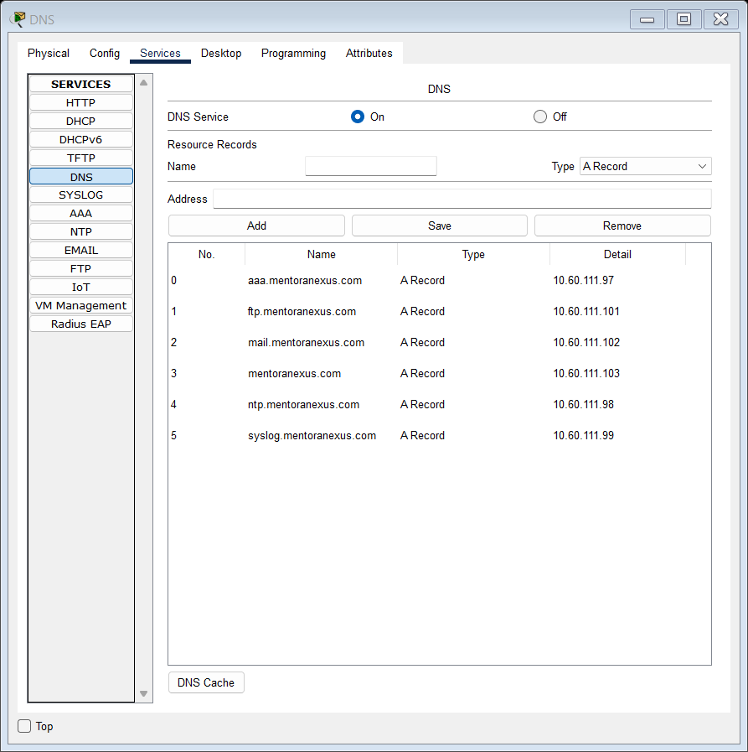

Screenshot x.x – Codeport’s DNS server configuration instance.

## Hypertext Transfer Protocol (HTTP/HTTPS)

HTTP defines the **stateless** communication model between **clients** (web browsers) and **web servers**, using request methods such as **GET, POST**, **PUT**, and **DELETE**. **HTTPS** incorporates **TLS/SSL** **encryption** to ensure **data confidentiality, integrity,** and **authenticity**. The **handshake process** establishes secure connections using **asymmetric encryption** before exchanging encrypted session data.

**HTTP** operates on **TCP port 80**; **HTTPS** uses **TCP port 443** for encrypted transmissions.

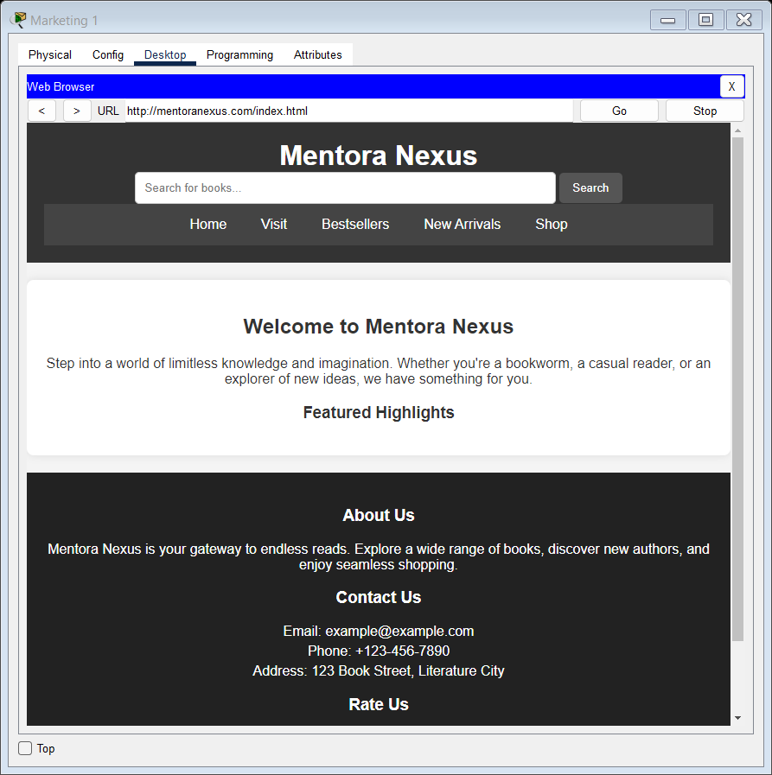

Screenshot x.x – PC accesses mentoranexus.com through Codeport’s HTTP server.

## File Transfer Protocol (FTP)

**FTP** facilitates **file exchanges** over a **client-server architecture** with dedicated **control** and **data** channels. **Active mode** initiates data transfer from the server to the client's specified port, while **passive mode** allows clients to establish the connection. FTP lacks inherent encryption but can be secured via **FTPS** (SSL/TLS) or **SFTP** (SSH-based).

Uses **TCP port 21** for command **control** and **TCP port 20** for active mode **data** transfers.

**IOS Commands Alongside Their Descriptions:**

|  |  |
| --- | --- |
| **Command** | **Description** |
| **ip ftp username** *username* | Specifies the username for the authentication |
| **ip ftp password** *password* | Specifies the password for the authentication |
| **copy** *source_file* **ftp:***//ftp_server_ip_address/destination_file* | Copy the specified file to the FTP server. |
| **Copy ftp:***//ftp_server_ip_address/source_file destination_file* | Copy the specified from the FTP server to the device. |

**Sample execution of specified commands**

CORE-RTR-C_PORT-1(config)#ip ftp username FullAccessUser

CORE-RTR-C_PORT-1(config)#ip ftp password 111FullAccessUser

CORE-RTR-C_PORT-1(config)#do copy startup-config ftp

Address or name of remote host []? ftp.mentoranexus.com

Destination filename [CORE-RTR-C_PORT-1-confg]?

Writing startup-config...Translating "ftp.mentoranexus.com"...domain server (10.60.111.100)

[OK - 4472 bytes]

4472 bytes copied in 0.021 secs (212000 bytes/sec)

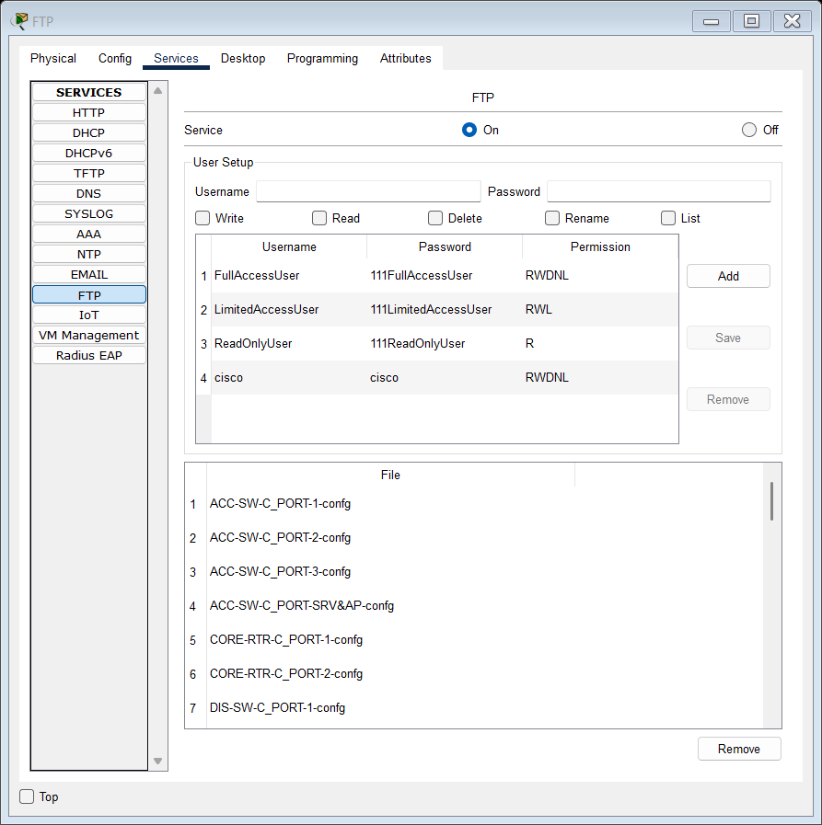

Screenshot x.x – Codeport’s FTP server file repository.

## Trivial File Transfer Protocol (TFTP)

**TFTP** is a **connectionless**, lightweight **file transfer** protocol designed for bootstrapping network devices and distributing firmware or configurations. It omits authentication and encryption, relying on **predefined file directories**.

Employs **UDP port 69**.

**IOS Commands Alongside Their Descriptions:**

|  |  |
| --- | --- |
| **Command** | **Description** |
| **copy** *source_file* **tftp:***//tftp_server_ip_address/destination_file* | Copy the specified file to the TFTP server. |

**Sample execution of specified commands**

CORE-RTR-T_VISTA-1(config)#do copy startup-config tftp

Address or name of remote host []? tftp.techvista.mentoranexus.com

Destination filename [CORE-RTR-T_VISTA-1-confg]?

Writing startup-config...Translating "tftp.techvista.mentoranexus.com"...!!

[OK - 5837 bytes]

5837 bytes copied in 0.02 secs (291850 bytes/sec)

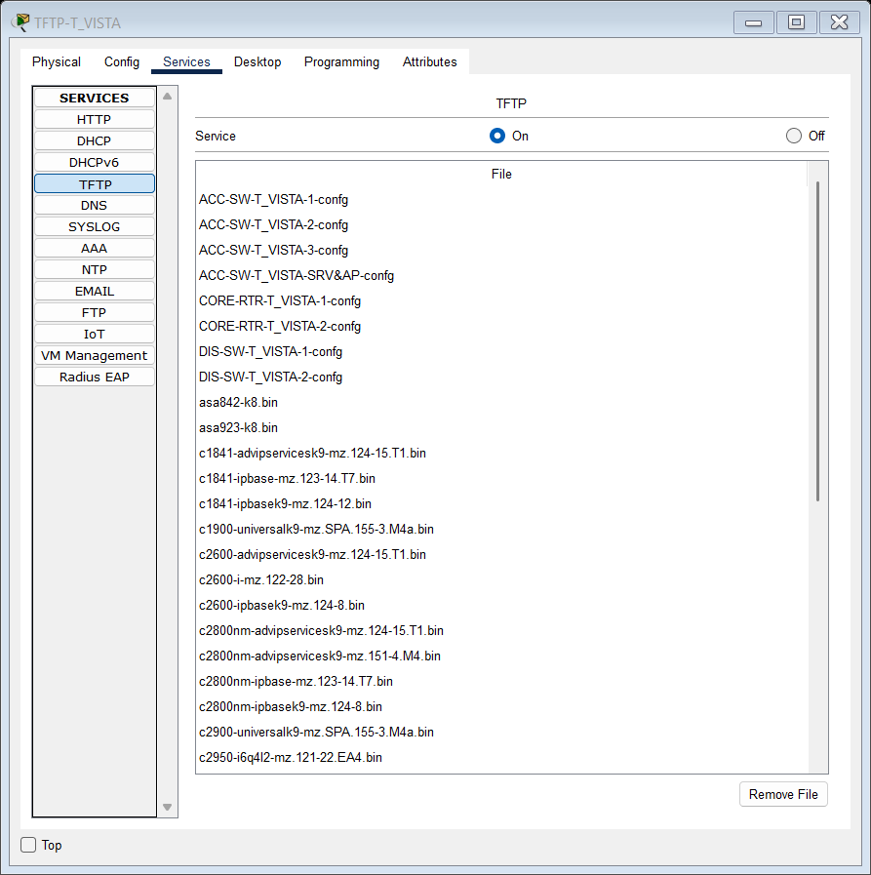

Screenshot x.x – TechVista’s TFTP server file repository

## Syslog Protocol

Syslog standardizes **event logging** across networked systems, structuring messages by **facility** (origin) and **severity** (importance). Messages can be forwarded to a remote **Syslog server** for **aggregation, analysis**, and **alerting**. Syslog messages have predefined value determining how severe they are. The lower this value, the more severe the message content, ranging from 0 to 7 with alternative terms (i.e., **debug** as an alternative for **7**).

Operates primarily over **UDP port 514**.

**IOS Commands Alongside Their Descriptions:**

|  |  |
| --- | --- |
| **Command** | **Description** |
| **logging on** | Enables transference of logging notifications to a remote Syslog server |
| **logging *syslog_server_ip_address*** | Specifies the Syslog server’s IP address for storing the network device’s syslog messages. |
| **logging trap** ***severity_level*** | The *severity*_*level* parameter defines which logging messages are to be sent to the syslog server with a default value of 7/debug. |

**Sample execution of specified commands**

CORE-RTR-T_VISTA-1(config)#logging on

CORE-RTR-T_VISTA-1(config)#logging 10.60.110.99

CORE-RTR-T_VISTA-1(config)#logging trap debugging

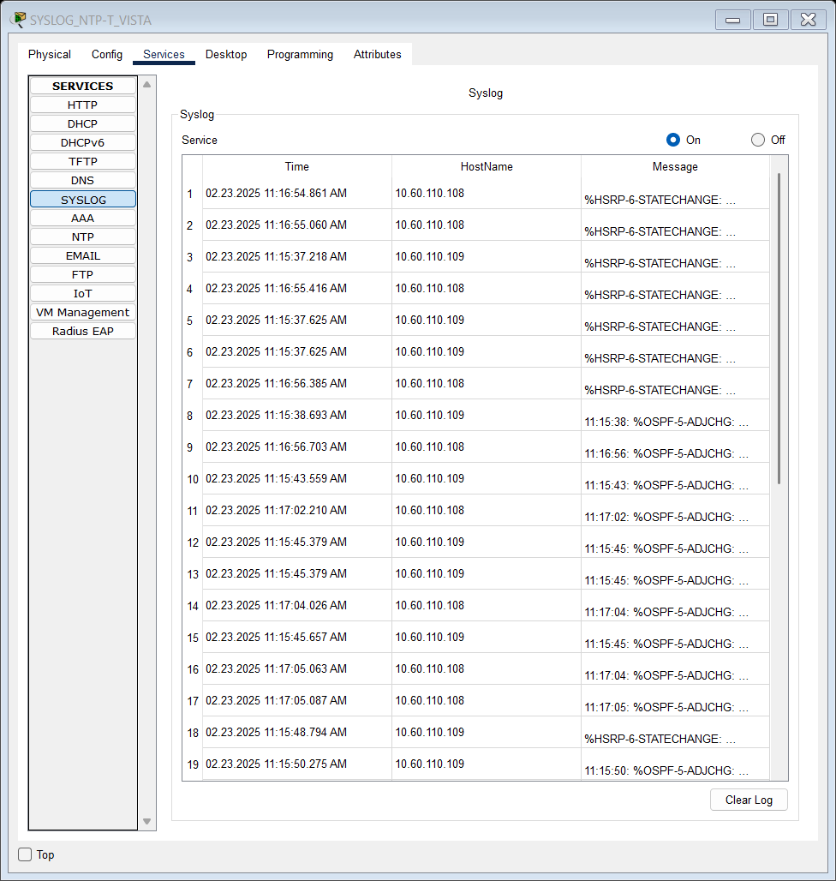

Screenshot x.x – TechVista’s Syslog server stores logging notifications.

## Network Time Protocol (NTP)

NTP ensures precise **clock synchronization** across network nodes by employing a **hierarchical, stratum-based architecture**. It mitigates clock drift using the **Marzullo algorithm** and statistical filtering. NTP clients synchronize with a **reference clock** (stratum 1) through **intermediate servers** (stratum 2+), adjusting local time accordingly.

Uses **UDP port 123** for time synchronization.

On multi-layer switches and routers, the `*ntp authentication-key*` command is persisted across reboots due to support for encrypted key storage. In contrast, Layer 2-only switches omit the key - even after `*copy running-config startup-config*` - because they lack persistent storage for encrypted secrets. To mitigate this situation, the SYSLOG server was concurrently configured as an unauthenticated NTP source for Layer 2 devices.

**IOS Commands Alongside Their Descriptions:**

|  |  |  |
| --- | --- | --- |
| **Method** | **Command** | **Description** |
| **Authentication-Oriented NTP Synchronization** | **ntp authenticate** | Enables NTP authentication, requiring valid keys for synchronization. |
| **ntp authentication-key** *key* **md5** *password* | Defines an NTP authentication key using MD5 encryption. |
| **ntp server** *ntp_server_ip_address* **key** *key_value* | Specifies an NTP server with authentication using a specified key . |
| **ntp update-calendar** | Syncs the hardware clock (calendar) with the NTP time. |
| **Authentication-Free NTP Synchronization** | **ntp server** *ntp_server_ip_address* | Specifies an NTP server without requiring authentication. |

**Sample execution of specified commands**

**Authentication-oriented implementation**

CORE-RTR-T_VISTA-1(config)#ntp authentication-key 110 md5 110NTP

CORE-RTR-T_VISTA-1(config)#ntp authenticate

CORE-RTR-T_VISTA-1(config)#ntp trusted-key 110

CORE-RTR-T_VISTA-1(config)#ntp server 10.60.110.98 key 110

CORE-RTR-T_VISTA-1(config)#ntp update-calendar

**Verifying using show commands**

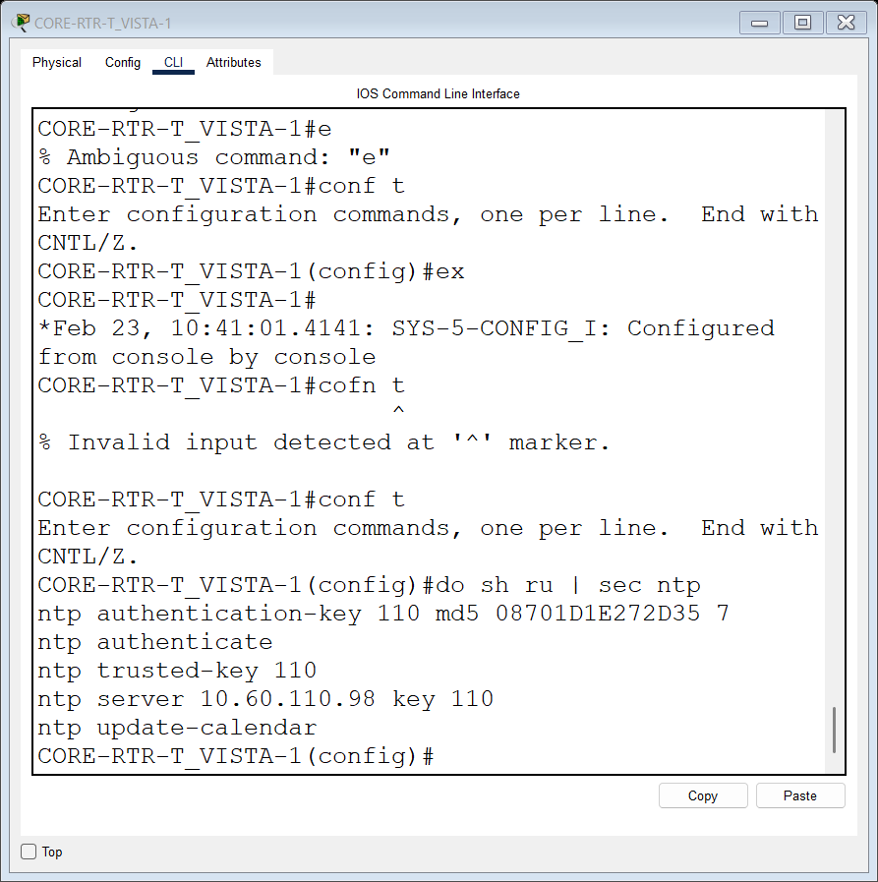

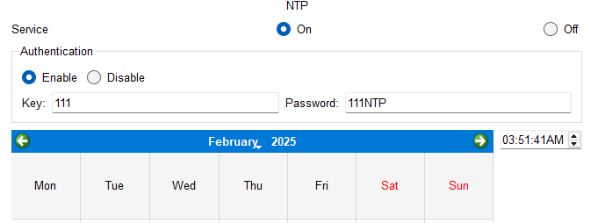

Screenshot x.x – TechVista’s authentication-oriented NTP server.

**Authentication-free implementation**

DIS-SW-T_VISTA-1(config)#ntp server 10.60.110.99

**Verifying using show commands**

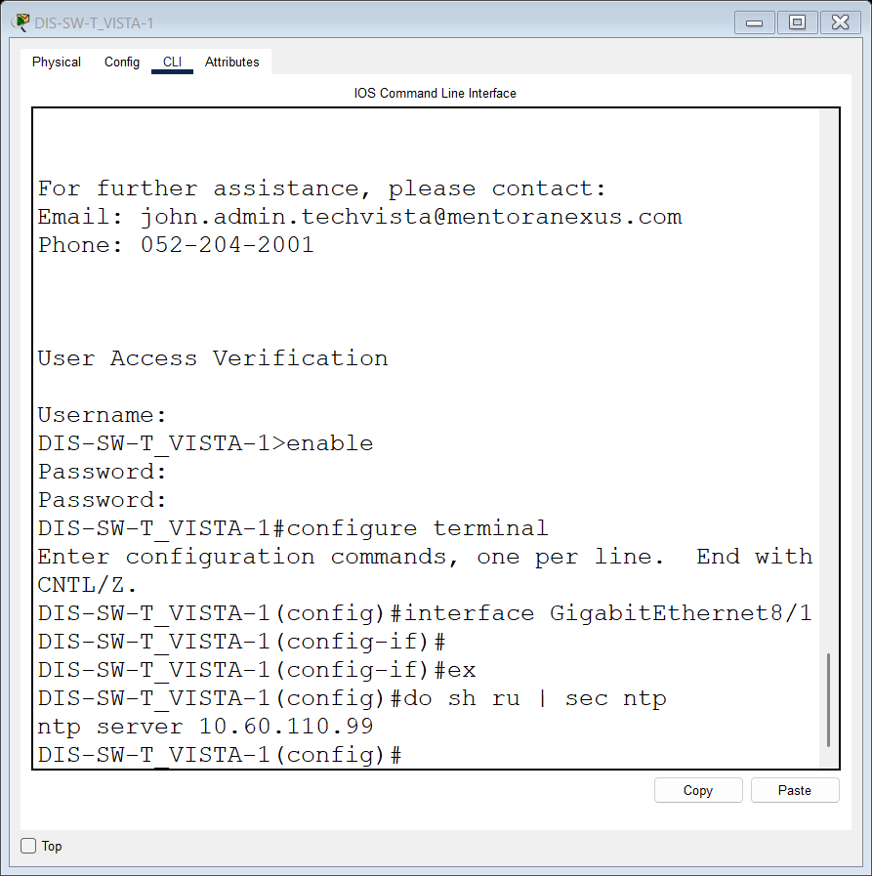

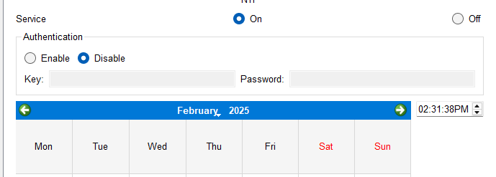

Screenshot x.x – TechVista’s authentication-free NTP server.

## Mail Protocols (SMTP, POP3, IMAP)

**SMTP** facilitates **mail transmission** between **mail servers**, while **POP3** and **IMAP** allow **client retrieval**. SMTP supports **STARTTLS** for encryption. IMAP provides **server-side** message management and concurrent multi-client access, whereas POP3 downloads messages **locally** and removes them from the server.

* SMTP: **TCP port 25** (relay), **587** (submission), **465** (TLS encryption).
* POP3: **TCP port 110** (unencrypted), **995** (SSL/TLS secure).
* IMAP: **TCP port 143** (unencrypted), **993** (SSL/TLS secure).

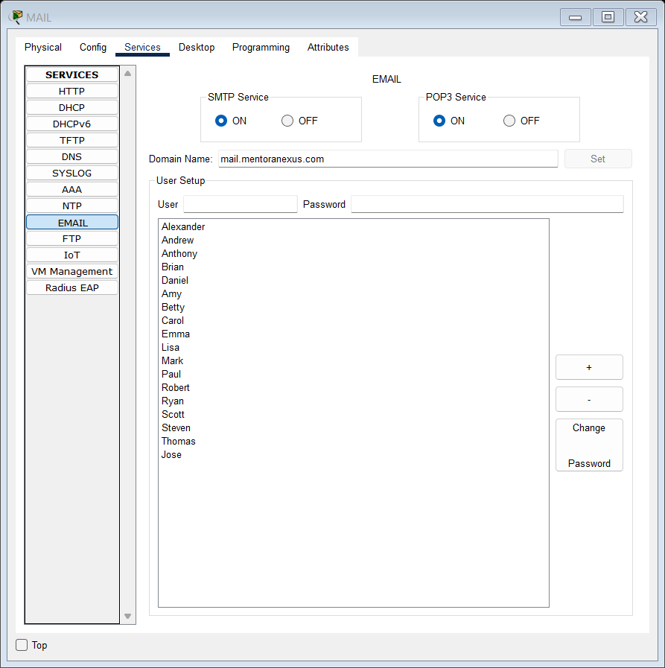

Screenshot x.x – Codeport’s MAIL server configuration instance.

**Illustration of Mail Exchange Between Two Employees**

**Configuring Email Clients on Employee Workstations.**

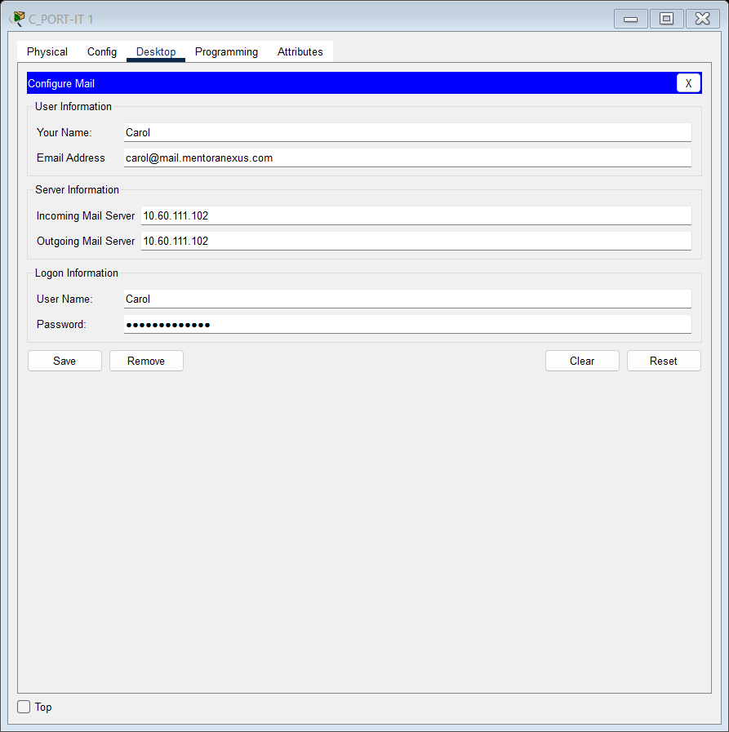

Screenshot x.x – Codeport PC1 mail configuration.

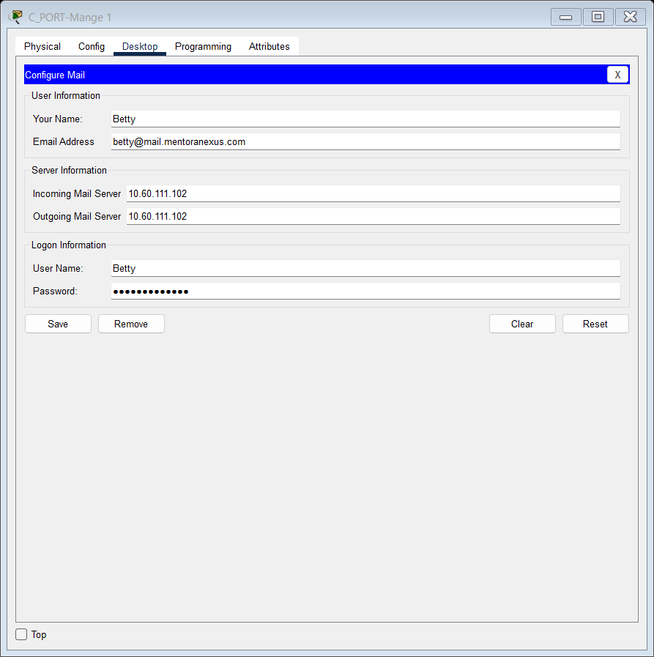

Screenshot x.x – Codeport PC2 mail configuration.

**Testing Mail messages exchange functionality**

1. **Transmission Initiation – PC1 (Carol) generates and transmits a test packet.**
2. **Reception and Response – PC2 (Betty) receives the packet, processes it, and transmits a correspondence response.**

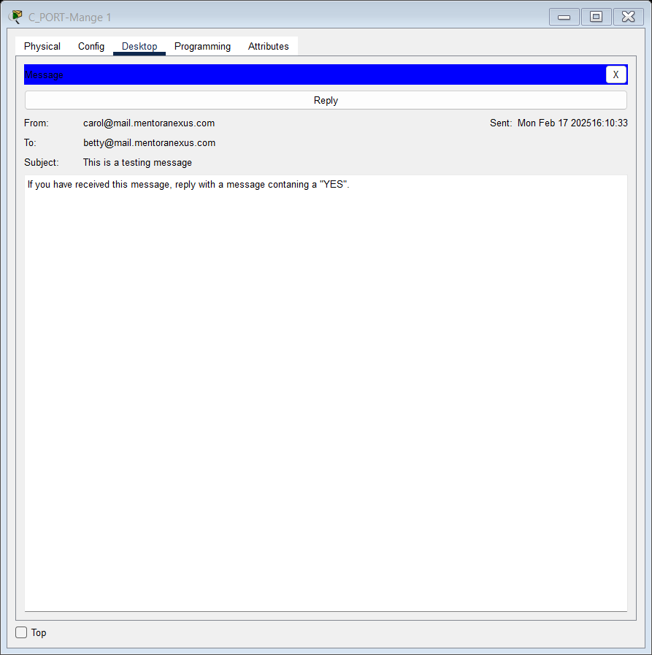

1. **Acknowledgement – PC1 successfully receives and validates the response from PC2, confirming bidirectional communication.**

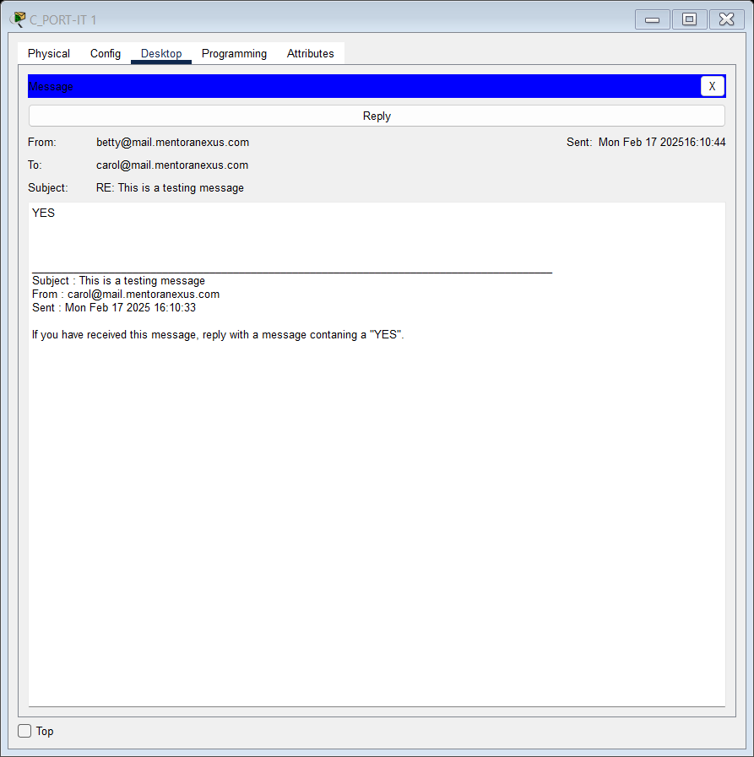

## Authentication, Authorization, & Accounting (AAA)

AAA enforces **security policies** by **authenticating** users, **authorizing** access levels, and **tracking** network activity. It integrates with **RADIUS** (connectionless, UDP-based) and **TACACS+** (connection-oriented, TCP-based) protocols. RADIUS is preferred for network access authentication, whereas TACACS+ is used for device management and command authorization.

* RADIUS: **UDP ports 1812** (authentication) and **1813** (accounting).
* TACACS+: **TCP port 49**.

Configuring Radius/Tacacs authentication on PT-empty switches is not feasible. Instead, I have configured local authentication on those switches.

**IOS Commands Alongside Their Descriptions:**

|  |  |
| --- | --- |
| **Command** | **Description** |
| **aaa new-model** | Enables the AAA (Authentication, Authorization, and Accounting) feature |
| **aaa authentication login default group tacacs+ local** | Configures login authentication using TACACS+, with local authentication as a fallback. |
| **aaa authorization exec default group tacacs+ local** | Enables command authorization via TACACS+, with local as a backup |
| **aaa accounting exec default start-stop group tacacs+** | Enables session accounting, logging start and stop events via TACACS+. |
| **username admin privilege** *level* **secret** *password* | Creates a user with a specified privilege level and encrypted password |
| **tacacs-server host** *tacacs_server_ip_address* | Defines the TACACS+ server's IP address for authentication. |
| **tacacs-server key** *key_value* | Sets the shared encryption key for TACACS+ communication |
| **login authentication default** | Applies the default AAA authentication method for login access on either VTY or Console connection or both. |

**Sample execution of specified commands**

CORE-RTR-C_PORT-1(config)#aaa new-model

CORE-RTR-C_PORT-1(config)#aaa authentication login default group tacacs+ local

CORE-RTR-C_PORT-1(config)#aaa authorization exec default group tacacs+ local

CORE-RTR-C_PORT-1(config)#aaa accounting exec default start-stop group tacacs+

CORE-RTR-C_PORT-1(config)#username admin privilege 15 secret 5 ADMIN

CORE-RTR-C_PORT-1(config)#tacacs-server host 10.60.111.97

CORE-RTR-C_PORT-1(config)#tacacs-server key 111TACACS

CORE-RTR-C_PORT-1(config)#line vty 0 4

CORE-RTR-C_PORT-1(config-line)#login authentication default

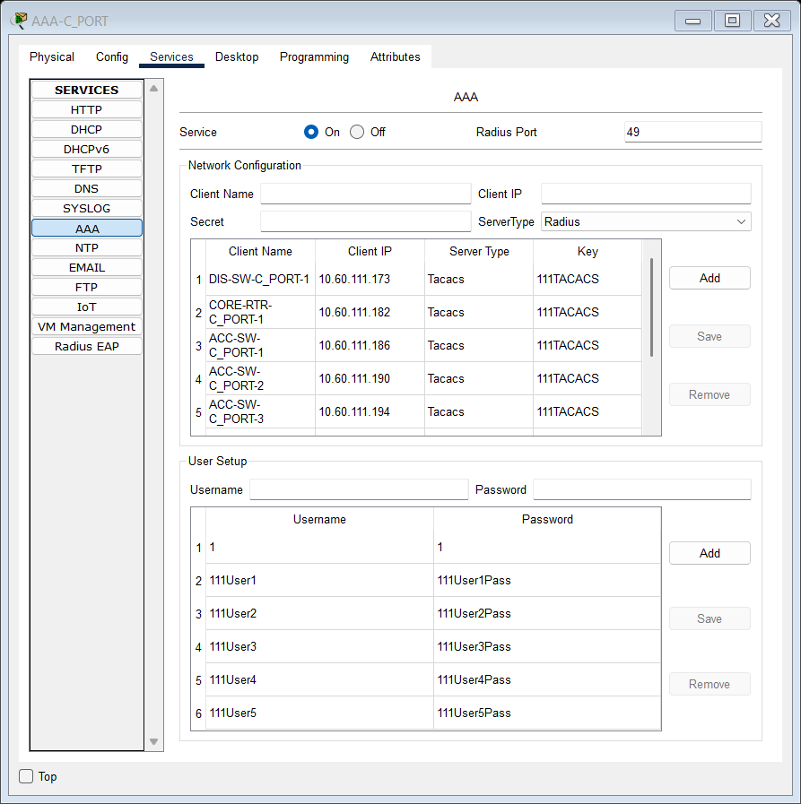

Screenshot x.x – Codeport’s AAA server configuration instance.

## Dynamic Host Configuration Protocol (DHCP)

DHCP **dynamically** **allocates** IP addresses, subnet masks, default gateways, and DNS settings to clients. In a **router-based role**, it assigns addresses within a defined pool. As a **dedicated server**, it supports lease durations, reservations, and scope policies. DHCP relies on the **DORA** (Discovery, Offer, Request, Acknowledgment) process.

Uses **UDP port 67** (server) and **68** (client).

**IOS Commands Alongside Their Descriptions**

|  |  |
| --- | --- |
| **Command** | **Description** |
| **ip dhcp excluded-address** *ip_address* | Excludes specific IP addresses from being assigned by the DHCP server. |
| **ip dhcp pool vlan***VLAN_Number* | Creates a DHCP pool for a specific VLAN and enters DHCP configuration mode |
| **network** *subnet_address**subnet_mask* | Defines the subnet and subnet mask for the DHCP pool. |
| **default-router** *default***_***gateway_ip_address* | Assigns the default gateway for DHCP clients. |
| **dns-server** *dns_server_ip_address* | Specifies the DNS server IP address for DHCP clients. |
| **Ip helper-address** *dhcp_server_ip_address* | Specifies the configured device to act as a DHCP relay agent |

**Sample execution of specified commands**

**Internal DHCP configuration**

ACC-SW-C_PORT-3(config)#ip dhcp excluded-address 10.60.111.14

ACC-SW-C_PORT-3(config)#ip dhcp excluded-address 10.60.111.30

ACC-SW-C_PORT-3(config)#ip dhcp pool vlan110

ACC-SW-C_PORT-3(dhcp-config)# network 10.60.111.0 255.255.255.240

ACC-SW-C_PORT-3(dhcp-config)# default-router 10.60.111.14

ACC-SW-C_PORT-3(dhcp-config)# dns-server 10.60.111.100

ACC-SW-C_PORT-3(dhcp-config)#ip dhcp pool vlan115

ACC-SW-C_PORT-3(dhcp-config)# network 10.60.111.16 255.255.255.240

ACC-SW-C_PORT-3(dhcp-config)# default-router 10.60.111.30

ACC-SW-C_PORT-3(dhcp-config)# dns-server 10.60.111.100

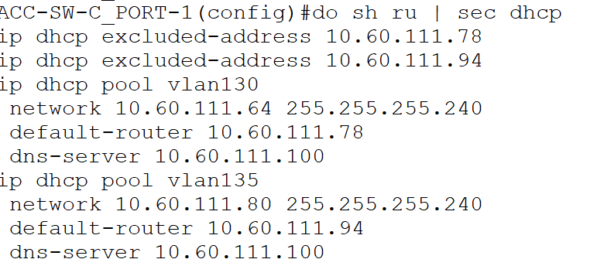

**Example External DHCP configuration for VLAN 65**

CORE-RTR-T_VISTA-1(config)#interface GigabitEthernet0/0.65

CORE-RTR-T_VISTA-1(config-subif)#ip helper-address 10.60.110.100

**External DHCP configuration**

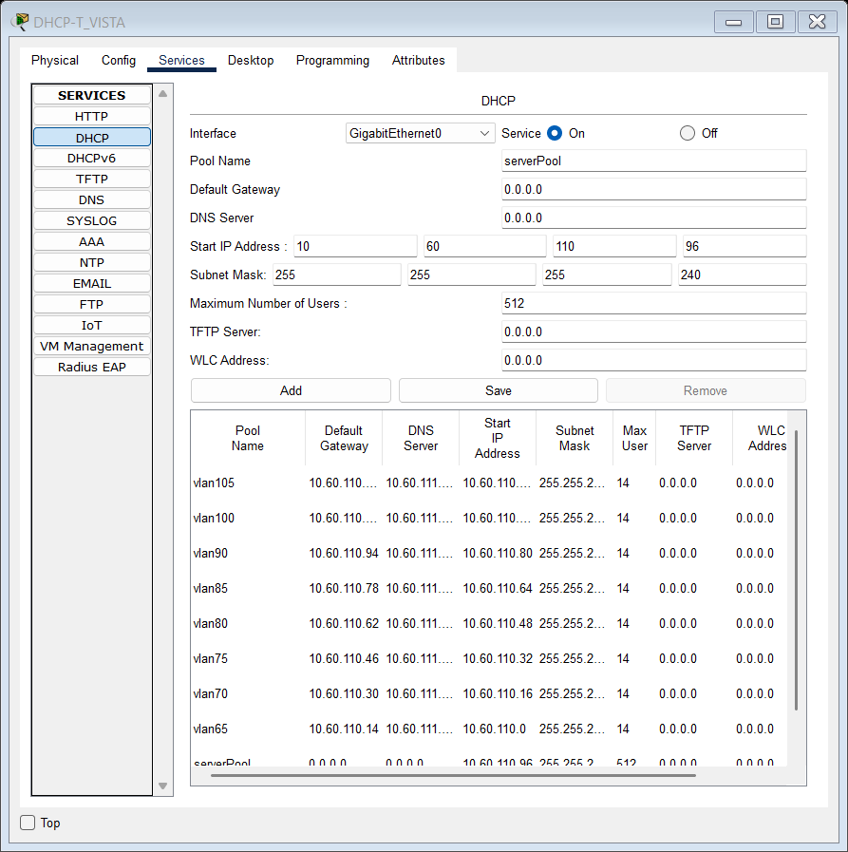

Screenshot x.x – TechVista’s external DHCP server configuration instance.

# Routing Protocols

## Open Shortest Path First (OSPF)

OSPF is an **intra-autonomous system,** **link-state** **routing protocol** that constructs a **complete network topology** using Link-State Advertisements (**LSAs**). It employs the **Dijkstra SPF algorithm** to calculate the shortest path. OSPF operates in hierarchical areas, reducing routing overhead. It supports equal-cost multipath (**ECMP**) and fast convergence.

Uses **IP protocol 89** (non-TCP/UDP).

Administrative Distance (**AD**): **110**.

**IOS Commands Alongside Their Descriptions:**

|  |  |
| --- | --- |
| **Command** | **Description** |
| **router ospf** *process_id* | Enables OSPF, assigns a process ID, and enters OSPF configuration mode |
| **router-id** *id_value* | |  | | --- | | Manually sets the OSPF router ID. |  |  | | --- | |  | |
| **low-adjacency-changes** | |  | | --- | | Minimizes OSPF adjacency flaps by reducing unnecessary changes. |  |  | | --- | |  | |
| **network** *subnet_address subnet_mask* **area** *area_number* | |  | | --- | | Assigns a network to an OSPF area. |  |  | | --- | |  | |
| **default-information-originate** | Advertises a default route to OSPF neighbors. |
| **passive interface** *interface_name* | Prevents OSPF from sending hello packets on a specific interface while still advertising the network. |
| **show ip ospf neighbor** | Displays OSPF neighbors and their states. |
| **show ip ospf database** | Displays OSPF LSAs and the link-state database. |
| **show ip ospf interface** | Displays OSPF interface details, including cost, hello/dead timers, and adjacency status. |

**Sample execution of specified commands**

DIS-SW-C_PORT-1(config)#router ospf 1

DIS-SW-C_PORT-1(config-router)#router-id 3.3.3.3

DIS-SW-C_PORT-1(config-router)#log-adjacency-changes

DIS-SW-C_PORT-1(config-router)#network 10.60.111.180 0.0.0.3 area 0

DIS-SW-C_PORT-1(config-router)#network 10.60.111.176 0.0.0.3 area 0

DIS-SW-C_PORT-1(config-router)#network 10.60.111.160 0.0.0.3 area 0

DIS-SW-C_PORT-1(config-router)#network 10.60.111.164 0.0.0.3 area 0

DIS-SW-C_PORT-1(config-router)#network 10.60.111.168 0.0.0.3 area 0

DIS-SW-C_PORT-1(config-router)#network 10.60.111.172 0.0.0.3 area 0

DIS-SW-C_PORT-1(config-router)#network 10.60.111.133 0.0.0.0 area 0

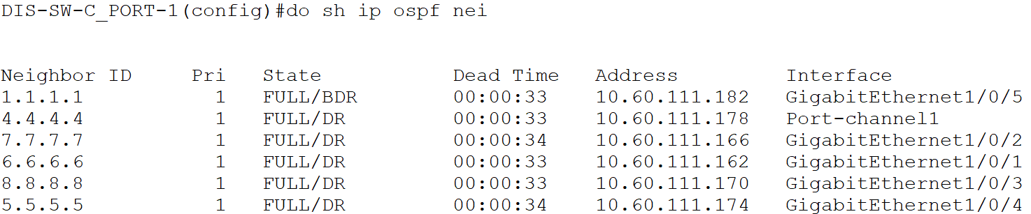

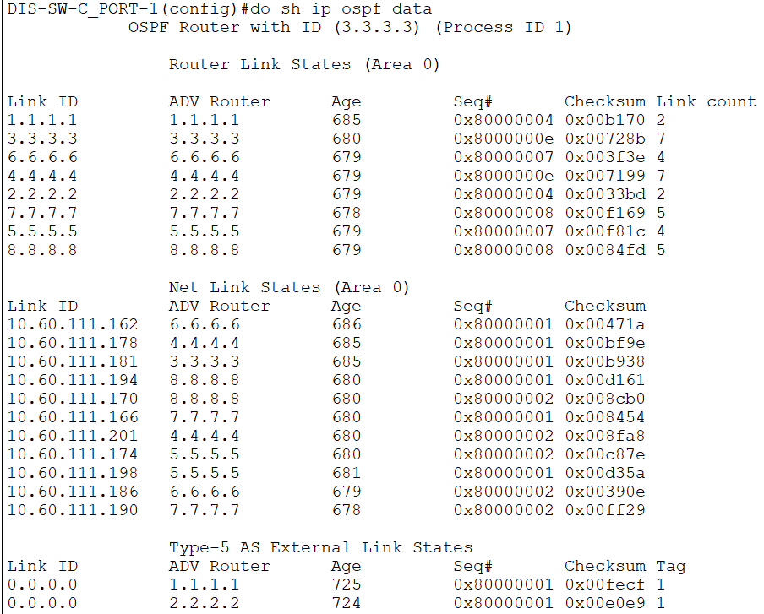

## 

## Enhanced Interior Gateway Routing Protocol (EIGRP - Cisco Proprietary)

EIGRP is an **intra-autonomous system,** **advanced distance-vector** routing protocol **integrating link-state** characteristics. It employs the Diffusing Update Algorithm (**DUAL**) for **loop-free** route computation, supports unequal-cost multipath (**UCMP**) routing, and maintains a topology table for rapid convergence.

Uses **IP protocol 88**.

Administrative Distance (**AD**): **90** (internal routes), **170** (external routes).

## Border Gateway Protocol (BGP)

BGP is an **inter-autonomous system routing protocol** employing **path-vector** mechanics. It utilizes attributes such as **AS-PATH, NEXT-HOP, LOCAL_PREF**, and **MED** for path selection. **IBGP** (internal) operates within an AS, while **EBGP** (external) facilitates inter-AS routing.

Uses **TCP port 179.** Administrative Distance (**AD**): **20** (EBGP), **200** (IBGP).

**IOS Commands Alongside Their Descriptions:**

|  |  |
| --- | --- |
| **Command** | **Description** |
| **router bgp** *ASN* | Enables BGP, assigns an Autonomous System Number (ASN) and enters BGP configuration mode |
| **[no] bgp log-neighbor-changes** | Logs BGP neighbor state changes; no disables logging |
| **no synchronization** | Disables the synchronization rule, allowing BGP to advertise routes without requiring IGP knowledge |
| **neighbor** *neighbor_ip_address* **remote-as** *neighbor_ASN* | Configures a BGP neighbor and assigns its remote ASN. |
| **network** *network_address* **mask** *network_mask* | Advertises a network into BGP using the specified subnet mask. |
| **no auto-summary** | Disables automatic summarization of classful networks in BGP. |
| **show ip bgp summary** | Displays a summary of BGP neighbors and statistics. |
| **show ip bgp neighbors** | Shows detailed information about BGP neighbor relationships. |

**Sample execution of specified command**

ISP-RTR-1(config)#router bgp 10

ISP-RTR-1(config-router)# bgp log-neighbor-changes

ISP-RTR-1(config-router)# no synchronization

ISP-RTR-1(config-router)# neighbor 200.200.200.2 remote-as 20

ISP-RTR-1(config-router)# neighbor 200.200.200.3 remote-as 30

ISP-RTR-1(config-router)# neighbor 110.110.110.1 remote-as 110

ISP-RTR-1(config-router)# neighbor 110.110.110.2 remote-as 110

ISP-RTR-1(config-router)# network 200.200.200.0 mask 255.255.255.248

ISP-RTR-1(config-router)# network 110.110.110.0 mask 255.255.255.248

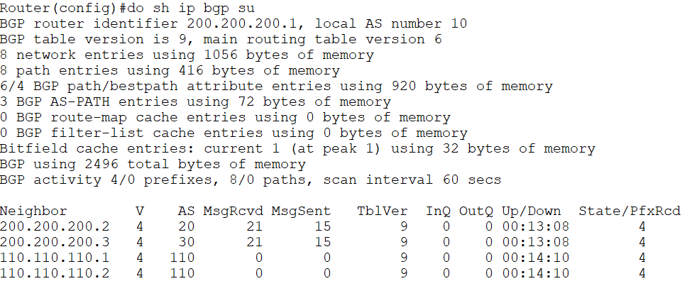

# 

# Layer 3 Protocols

## Hot Standby Router Protocol (HSRP - Cisco Proprietary)

HSRP establishes a **virtual gateway** by electing an **active** and **standby** router, ensuring high availability through **priority-based failover**. **Preemption** and tracking mechanisms adjust roles dynamically.

Operates over **UDP port 1985**.

**IOS Commands Alongside Their Descriptions:**

|  |  |
| --- | --- |
| **Command** | **Description** |
| **standby** *group_num* **ip** *virtual_ip_address* | Configures the virtual IP address for the HSRP group. |
| **standby** *group_num* **priority** *priority_value* | Sets the router's HSRP priority (higher value = preferred active router). |
| **standby** *group_num* **preempt** | Enables preemption, allowing a higher-priority router to take over the active role. |
| **show standby** | Displays HSRP status, including active/standby roles and timers. |

**Sample execution of specified commands**

**R1 – active for VLAN 65**

CORE-RTR-T_VISTA-1(config)#interface GigabitEthernet0/0.65

CORE-RTR-T_VISTA-1(config-subif)#encapsulation dot1Q 65

CORE-RTR-T_VISTA-1(config-subif)#ip address 10.60.110.12 255.255.255.240

CORE-RTR-T_VISTA-1(config-subif)#ip helper-address 10.60.110.100

CORE-RTR-T_VISTA-1(config-subif)#standby 65 ip 10.60.110.14

CORE-RTR-T_VISTA-1(config-subif)#standby 65 priority 110

CORE-RTR-T_VISTA-1(config-subif)#standby 65 preempt

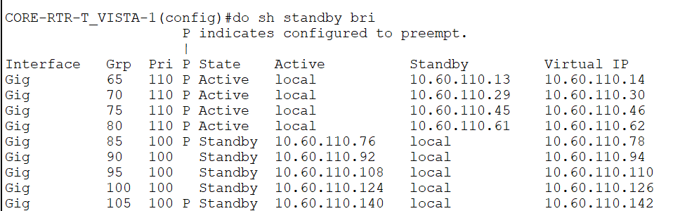

**R2 – standby for VLAN 65**

CORE-RTR-T_VISTA-2(config)#interface GigabitEthernet0/0.65

CORE-RTR-T_VISTA-2(config-subif)#encapsulation dot1Q 65

CORE-RTR-T_VISTA-2(config-subif)#ip address 10.60.110.13 255.255.255.240

CORE-RTR-T_VISTA-2(config-subif)#ip helper-address 10.60.110.100

CORE-RTR-T_VISTA-2(config-subif)#standby 65 ip 10.60.110.14

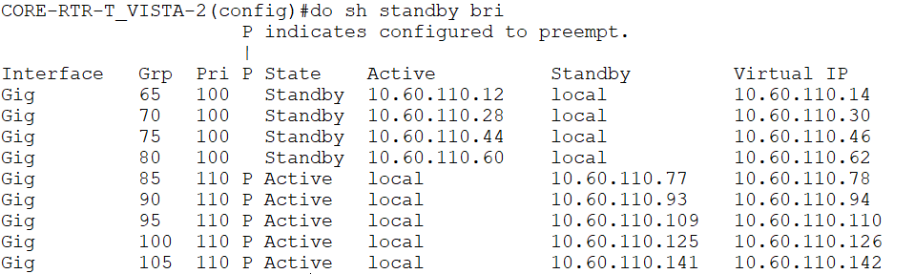

## 

## IPsec Virtual Private Network (IPsec VPN)

IPsec **secures** IP communications via Encapsulating Security Payload (**ESP**) for **encryption** and Authentication Header (**AH**) for **integrity** verification. **IKE** (Internet Key Exchange) negotiates security parameters, supporting **Main** and **Aggressive** modes for **Phase 1** key exchange.

Uses **UDP port 500** (IKE negotiation), **ESP** (IP protocol 50), **AH** (IP protocol 51).

**IOS Commands Alongside Their Descriptions:**

## Generic Routing Encapsulation (GRE)

GRE **encapsulates** Layer 3 packets, enabling tunneling over incompatible networks. It lacks intrinsic encryption, necessitating **IPsec integration** for confidentiality. **GRE tunnels** establish **stateless, point-to-point links**.

Encapsulation occurs under **IP protocol 47**.

**IOS Commands Alongside Their Descriptions:**

|  |  |
| --- | --- |
| **Command** | **Description** |
| **interface Tunnel***Tunnel_ID* | Creates and enters a tunnel interface configuration mode |
| **ip address** *tunnel_ip_address tunnel_subnet_mask* | Assigns an IP address and subnet mask to the tunnel interface |
| **tunnel source** *interface_name* | |  | | --- | | Specifies the source interface for the tunnel. |  |  | | --- | |  | |
| **tunnel destination** *peer_ip_address* | Defines the remote peer’s IP address as the tunnel endpoint. |
| **show interfaces tunnel** *Tunnel_ID* | |  | | --- | | Displays the status, IP address, MTU, and encapsulation type of the GRE tunnel. |  |  | | --- | |  | |

**Sample execution of specified commands**

CORE-RTR-T_VISTA-1(config)#interface Tunnel11011101

CORE-RTR-T_VISTA-1(config-if)#ip address 192.168.1.1 255.255.255.252

CORE-RTR-T_VISTA-1(config-if)#tunnel source GigabitEthernet0/0/0

CORE-RTR-T_VISTA-1(config-if)#tunnel destination 111.111.111.1

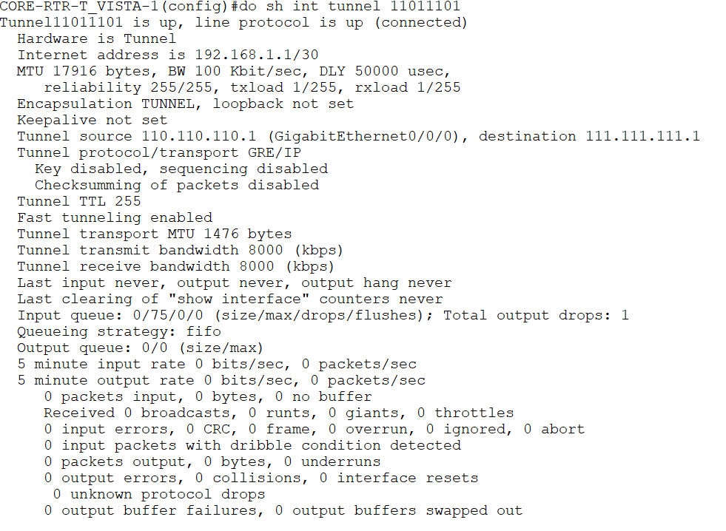

## 

## EtherChannel (Cisco Proprietary)

EtherChannel **aggregates** multiple physical links into a **single logical interface**, increasing bandwidth and redundancy. It supports **static**, **PAgP** (Cisco proprietary), and **LACP** (IEEE 802.3ad) negotiation.

LACP utilizes multicast **MAC address 01-80-C2-00-00-02.**

**Note: EtherChannel can also operates as a layer 2 protocol despite its present in this section.**

**IOS Commands Alongside Their Descriptions:**

|  |  |
| --- | --- |
| **Command** | **Description** |
| **Interface Port-channel***ID* | Creates and enters a Port-Channel (EtherChannel) interface configuration mode. |
| **channel-group** *Port-channelID* **mode on** | Assigns an interface to a Port-Channel and forces static EtherChannel (no negotiation). |
| **show etherchannel summary** | |  | | --- | | Displays EtherChannel status and configuration. |  |  | | --- | |  | |
| **show etherchannel port-channel** | Provides details of the Port-Channel interface. |

**Sample execution of specified commands**

DIS-SW-C_PORT-1(config)#interface Port-channel1

DIS-SW-C_PORT-1(config-if)#no switchport

*Feb 24, 04:46:00.4646: %LINEPROTO-5-UPDOWN: Line protocol on Interface Port-channel1, changed state to down

*Feb 24, 04:46:00.4646: %LINEPROTO-5-UPDOWN: Line protocol on Interface Port-channel1, changed state to up

DIS-SW-C_PORT-1(config-if)#ip address 10.60.111.177 255.255.255.252

DIS-SW-C_PORT-1(config-if)#interface GigabitEthernet1/0/23

DIS-SW-C_PORT-1(config-if)#no switchport

DIS-SW-C_PORT-1(config-if)#no ip address

DIS-SW-C_PORT-1(config-if)#channel-group 1 mode on

DIS-SW-C_PORT-1(config-if)#interface GigabitEthernet1/0/24

DIS-SW-C_PORT-1(config-if)#no switchport

DIS-SW-C_PORT-1(config-if)#no ip address

DIS-SW-C_PORT-1(config-if)#channel-group 1 mode on

DIS-SW-C_PORT-1(config-if)#

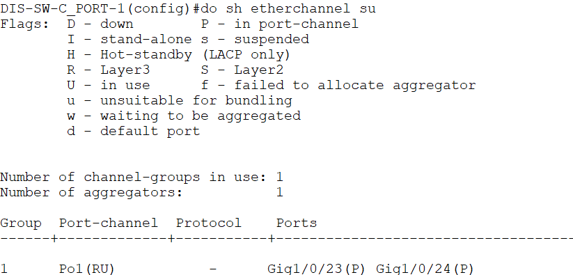

# 

# Layer 2 Protocols

## VLAN Trunking Protocol (VTP - Cisco Proprietary)

VTP **synchronizes** **VLAN databases** across switches, reducing administrative overhead. It functions in **server**, **client**, and **transparent** modes, with version 3 supporting **MST** (Multiple Spanning Tree) integration. Uses multicast **MAC address 01-00-0C-CC-CC-CC** on VLAN 1.

**IOS Commands Alongside Their Descriptions:**

|  |  |
| --- | --- |
| **Command** | **Description** |
| **vtp mode (***transport / client / server***)** | Sets the VTP mode: **server** (can create, modify, and propagate VLANs), **client** (receives updates but cannot create VLANs), or **transparent** (forwards updates but does not participate in VTP). |
| **vtp domain** *domain_name* | |  | | --- | | Assigns the switch to a specific VTP domain for VLAN synchronization. |  |  | | --- | |  | |
| **vtp password** *pass* | |  | | --- | | Configures a password for VTP authentication, ensuring only authorized switches can exchange VLAN information. |  |  | | --- | |  | |
| **vtp version** *ver* | |  | | --- | | Specifies the VTP version (1, 2, or 3), affecting features and VLAN propagation. |  |  | | --- | |  | |
| **[no] vtp pruning** | |  | | --- | | Enables **VTP pruning**, which limits VLAN traffic to only switches that need it. |  |  | | --- | |  | |
| **show vtp status** | |  | | --- | | Displays VTP configuration details, including mode, domain, version, and VLAN statistics. |  |  | | --- | |  | |
| **show vtp counters** | Shows VTP message statistics, including advertisements sent, received, and errors. |

**Sample execution of specified commands**

DIS-SW-T_VISTA-1(config)#vtp mode server

Setting device to VTP SERVER mode.

DIS-SW-T_VISTA-1(config)#vtp domain mentoranexus.com

Changing VTP domain name from . to mentoranexus.com

DIS-SW-T_VISTA-1(config)#vtp password vtp1234

Setting device VLAN database password to vtp1234

DIS-SW-T_VISTA-1(config)#vtp version 2

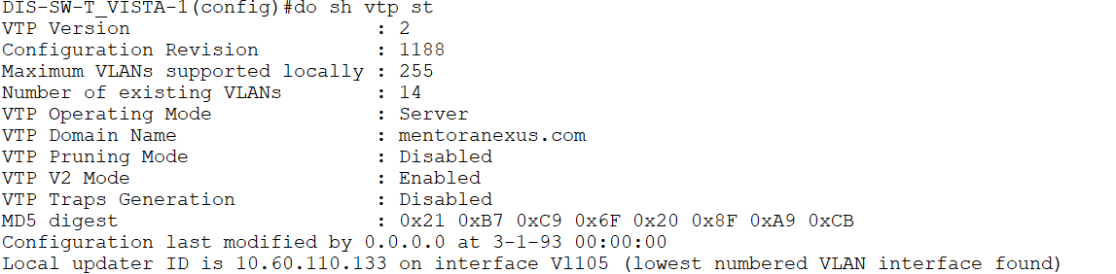

## 

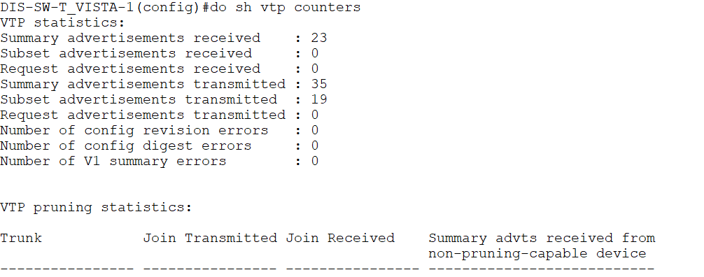

## Rapid Spanning Tree Protocol (RSTP - IEEE 802.1w)

RSTP optimizes **spanning tree convergence** using **port roles** (**Root, Designated, Alternate, Backup**) and introduces proposal/agreement mechanisms. It improves upon **802.1D** by eliminating timers in favor of immediate state transitions.

Operates via Bridge Protocol Data Units (**BPDUs**) within IEEE **802.1D frames**.

**IOS Commands Alongside Their Descriptions:**

|  |  |
| --- | --- |
| **Command** | **Description** |
| **spanning-tree mode** *( pvst / rapid-pvst )* | Selects PVST or Rapid PVST mode |
| **spanning-tree vlan** *vlan_id* **priority** *priority_value* | |  | | --- | | Sets the spanning-tree priority for a specific VLAN. |  |  | | --- | |  | |
| |  | | --- | |  |   **spanning-tree vlan** *vlan_id* **root (***primary / secondary***)** | |  | | --- | |  | | |  | | --- | | Configures the switch as the primary / secondary root bridge for a specific VLAN. |  |  | | --- | |  | | |
| **spanning-tree portfast** | |  | | --- | |  |   Enables PortFast on an interface, allowing it to transition to forwarding state immediately. |
| |  | | --- | | **spanning-tree bpduguard enable** |  |  | | --- | |  | | |  | | --- | | Enables BPDU Guard, disabling ports that receive BPDU packets. |  |  | | --- | |  | |
| |  | | --- | | **show spanning-tree** |  |  | | --- | |  | | |  | | --- | | Displays spanning-tree status and configuration details. |  |  | | --- | |  | |

**Sample execution of specified commands**

ACC-SW-T_VISTA-1(config)#spanning-tree mode pvst

ACC-SW-T_VISTA-1(config)#spanning-tree vlan 65,70,75,80,85,90,95,100,105 priority 24576

ACC-SW-T_VISTA-1(config)#interface FastEthernet0/1

ACC-SW-T_VISTA-1(config-if)#spanning-tree portfast

%Warning: portfast should only be enabled on ports connected to a single

host. Connecting hubs, concentrators, switches, bridges, etc... to this

interface when portfast is enabled, can cause temporary bridging loops.

Use with CAUTION

%Portfast has been configured on FastEthernet0/1 but will only

have effect when the interface is in a non-trunking mode.

ACC-SW-T_VISTA-1(config-if)#spanning-tree bpduguard enable

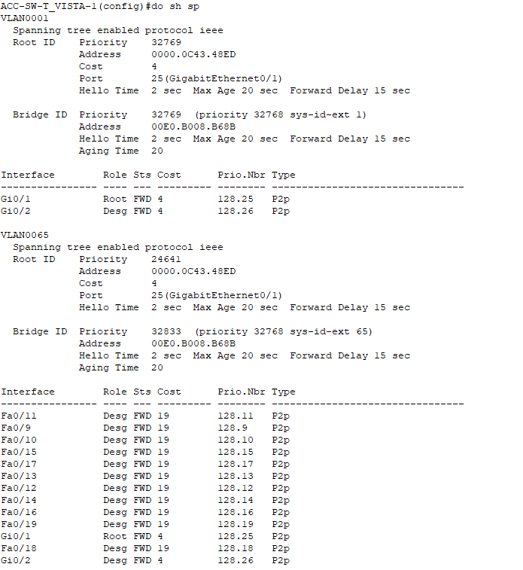

## Trunking (IEEE 802.1Q - Dot1Q)

802.1Q **encapsulates VLAN information** within Ethernet frames using a **4-byte tag**, ensuring VLAN segmentation over a single trunk link. It designates a **Native VLAN** for untagged traffic and supports **VLAN pruning** to optimize broadcast domains.

Encodes VLAN identifiers within Ethernet frames (no dedicated port).

**IOS Commands Alongside Their Descriptions:**

|  |  |
| --- | --- |
| **Command** | **Description** |
| **switchport mode trunk** | Sets the port to trunk mode, enabling multiple VLANs to traverse the link. |
| **switchport trunk encapsulation dot1q** | |  | | --- | | Specifies 802.1Q as the trunking protocol. |  |  | | --- | |  | |
| **switchport trunk allowed vlan** *vlan_list* | |  | | --- | | Defines which VLANs are permitted to pass through the trunk. |  |  | | --- | |  | |
| **switchport trunk native vlan** *vlan_id* | |  | | --- | | Configures the VLAN ID that will be untagged on the trunk port (default is VLAN 1). |  |  | | --- | |  | |
| **show** *interface* **switchport** | |  | | --- | | Displays information about trunk ports, including allowed VLANs and encapsulation type. |  |  | | --- | |  | |
| **show vlan brief** | Lists all VLANs and their associated ports, helping to verify 802.1Q configurations. |

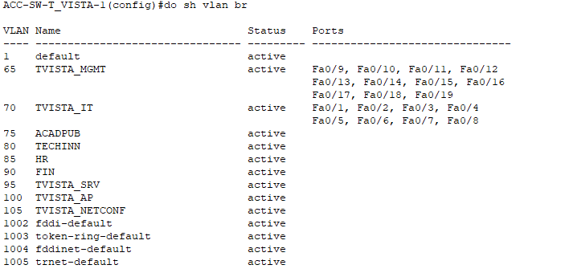

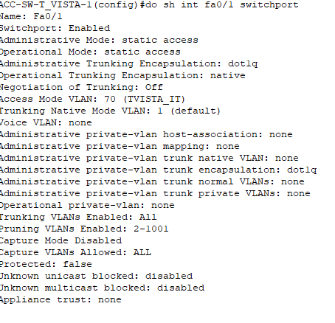

# Miscellaneous IOS Commands

## Device Identification and Basic Configuration

**hostname** *hostname-entry* modifies the device’s hostname.



**ip domain-name** *domain-name-value* defines the device's domain name. Employed in DNS lookups and SSH.



**ip default-gateway** *gateway-ip* sets the default gateway IP address for the device.

**

## Security, Authentication, and Line Connections

**enable secret** *secret-password* defines a secret password to be hashed for protecting privileged EXEC mode.



**enable password** plaintext-password defines a plaintext password to protect privileged EXEC mode.



**service password-encryption** encrypts plaintext passwords within the device’s configuration file.

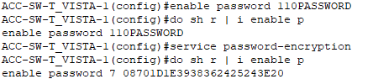

**ip ssh version** *<1|2>* specifies the SSH protocol version used by the device.

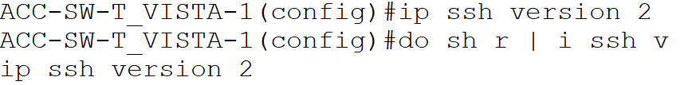

**crypto key generate rsa** *[modulus <512–2048>]* generates RSA key pairs to enable SSH secure connections.

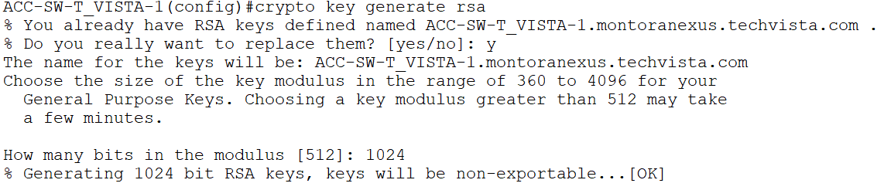

**login** *[local]* enables password checking; optionally specifies local username/password authentication.

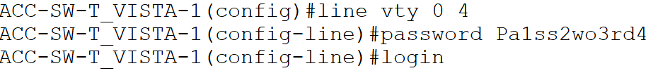

**line vty** *<0-4|0-15>* enters VTY line configuration for remote access sessions (SSH/Telnet).

**transport input** *<ssh | telnet | all | none>* specifies permitted protocols (SSH, Telnet, or both) for VTY line access.

**exec-timeout** *<minutes> [seconds]* sets idle timeout duration for console or VTY sessions.

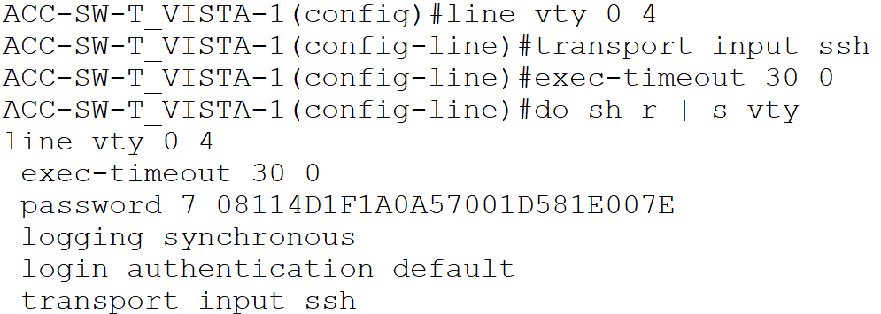

**ip arp inspection vlan** *<vlan-range>* enables Dynamic ARP Inspection on specified VLAN(s) to prevent ARP spoofing.



**ip dhcp snooping vlan** *<vlan-range>* enables DHCP snooping security feature on specified VLAN(s).



**interface** *<type number>* (e.g., GigabitEthernet0/1, FastEthernet0/0) enters interface configuration mode for the specified interface.

**ip arp inspection trust** marks an interface as trusted for Dynamic ARP Inspection purposes.

**ip dhcp snooping trust** configures the interface as trusted for DHCP snooping (allows DHCP server replies).

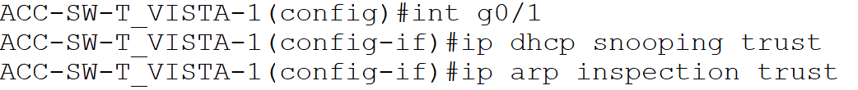

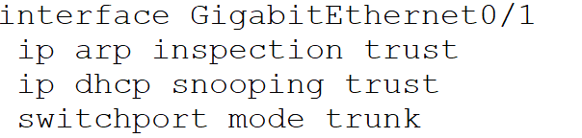

## Logging and Monitoring

**service timestamps log datetime msec** adds date, time, and millisecond precision to log messages.

**service timestamps debug datetime msec a**dds precise timestamps to debug messages for troubleshooting.



**line con 0** enters console line configuration mode for managing console port settings.

**logging synchronous e**nsures log and debug output do not interrupt command-line entry.

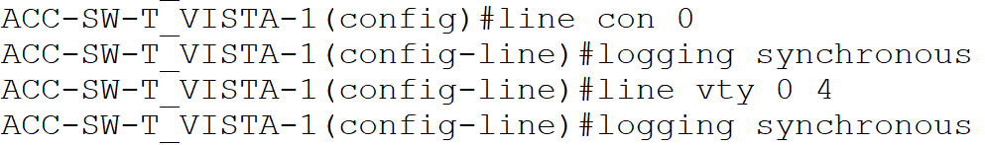

**show running-config** displays the active configuration currently running in memory.

**show startup-config** displays the configuration stored in NVRAM (startup configuration).

**show interfaces** *[type number]*provides detailed status and statistics for device interfaces.

**show ip protocols** displays active routing protocols and their configurations.

**show vlan brief** summarizes VLAN IDs, names, statuses, and assigned ports.

## Banner and User Access

**banner motd** *<delimiter>* **Your Message Here** *<delimiter>* defines a Message-of-the-Day banner displayed upon device login.

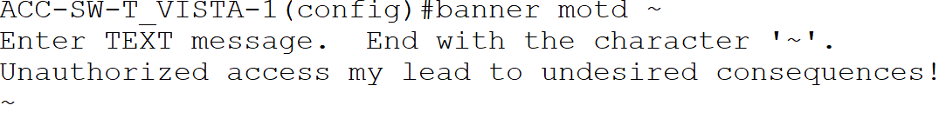

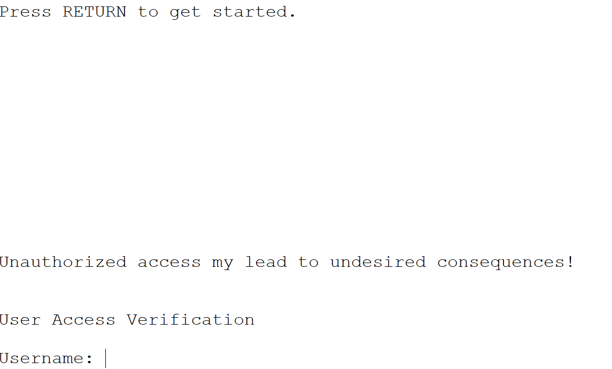

## VLAN and Interface Management

**no shutdown** activates (turns on) the specified interface or VLAN.

**vlan** *<vlan-id>* creates or enters configuration mode for a specific VLAN.

**name** *<vlan-name>* assigns a descriptive name to a VLAN.

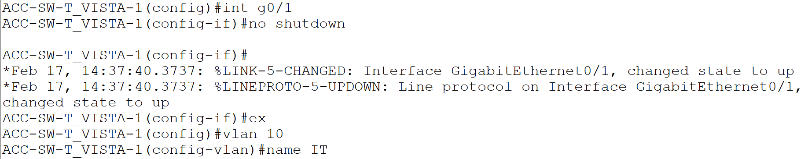

## Routing and ACL Management

**ip route** *<destination-network> <subnet-mask> <next-hop-ip | exit-interface>* defines a static route to a specified network via next-hop IP or exit interface.

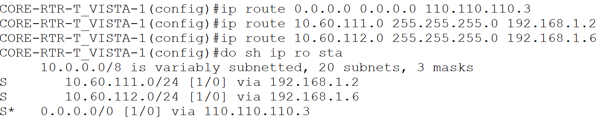

**ip access-list** *<standard | extended> <name | number>* **c**reates or modifies an IP access control list to filter network traffic.

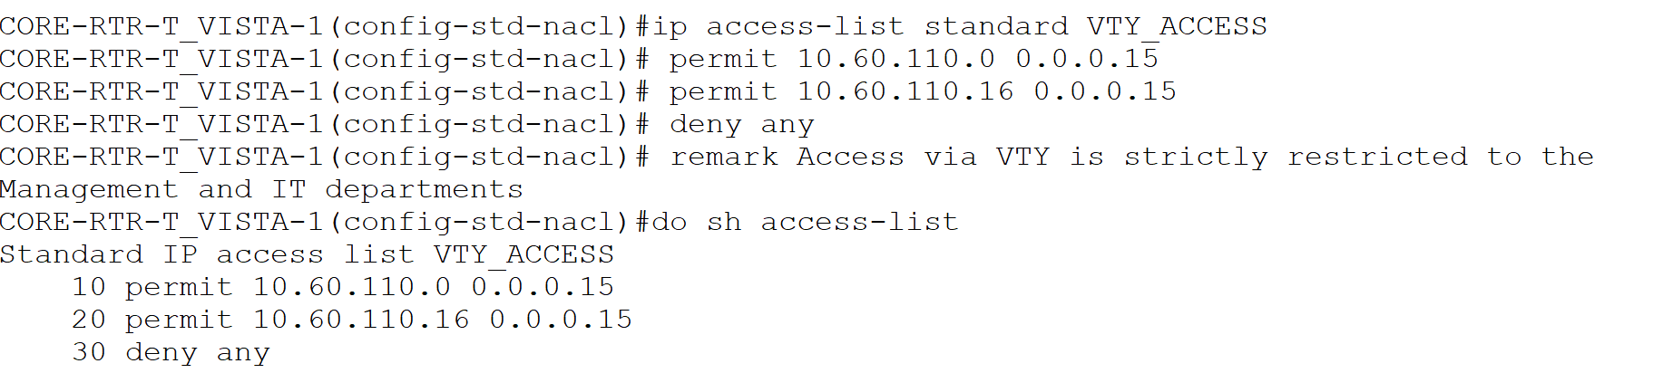

## Maintenance and Operational Commands

**write** *[memory]* (or equivalently copy running-config startup-config) saves current running configuration to NVRAM.

**reload** restarts the device (reboots IOS).

**clear** *<parameter>*(e.g., clear counters, clear ip route, clear arp-cache) clears specified operational or statistical information.

**no** *<command-to-negate>* removes or negates a previously applied command.

**no cdp run** disables Cisco Discovery Protocol globally on the device.